Replace Your Ride
ENVS 0401, Spring 2021

Sachi Howson, William Roberston, Maya Saterson, and Raquel Smith

Special thanks to our community partners Cara Robechek, Linda McGinnis, Peggy O’Neil, and David Roberts and our professors Jon Isham and Diane Munroe.
Table of Contents
Executive Summary 3
Background 3
Replace Your Ride 4
Project Objectives 5
GIS Mapping 5
Methods 5
Results 6
Discussion 19
Outreach 20
Car Dealership Phone Survey 20
Methods 20
Results 21
Used Car Dealerships 21
New Car Dealerships 25
Discussion 30
Used Car Dealerships 30
New Car Dealerships 31
Survey Development and Future Steps with Community Action Organizations 34
Methods 34
Results and Discussion 35
Conclusion and Future Steps 37
Appendix A: Baseline Maps 39
Registered Electric Vehicles in Vermont 39
Concentration of Electric Vehicles in Vermont 40
Transportation Burden in Vermont 41
Median Household Income in Vermont 42
Appendix B: Outreach Materials 43
Infographic 43
Car Dealership Script 44
Car Dealership Survey Data 46
Appendix C: Survey and Interview Questions 46
CAP Interview Questions 46
Participant Survey Questionnaire 46
Bibliography 52

Executive Summary
Currently, 40% of Vermont state’s carbon emissions come from the transportation sector, and transportation amounts to 45% of the total energy burden for Vermont. As the climate crisis becomes more urgent, efficient and effective carbon solutions, as well as environmental equity are key to reach our nation’s environmental goals. Replace Your Ride (RYR) is a Vermont state funded program to provide up to $3,000 cash incentives for clean transportation options for those who qualify as low-income Vermont residents. As part of the Middlebury College Environmental Studies Community Engagement Practicum, we were tasked to help identify and analyze gaps in the existing format of the program. As our final deliverables, we created GIS maps to show visual representations of relationships between existing charging stations, income, car dealerships, and vehicle model year presented the results from a phone survey with new and used car dealerships focused on assessing the effectiveness to sell electric vehicles with RYR incentives, and created another survey for possible participants as well as an accompanying outreach plan in partnership with community action organizations to be implemented in summer 2021. A core pillar of RYR is climate equity and justice which cannot be achieved unless programs listen to and support marginalized groups. The goal of the participant survey is to create an open dialogue with eligible Vermonters to assess any issues and voice concerns about the program, making RYR an inclusive climate and economic effort. By identifying potential barriers and community visions for this project, RYR will be able to adjust the existing structure in order to help Vermont significantly reduce its carbon footprint from transportation while also being more inclusive of marginalized communities in the fight against climate change. The results of this project show that outreach should be focused on bridging the gap between technology and awareness in the 4 southern counties of Vermont, particularly Rutland and Windham counties.

Background
With a new federal administration, electric vehicle use is finally gaining traction in the United States. Recently, President Joe Biden announced a 2 trillion dollar infrastructure plan to target climate change, which includes spending 174 billion to encourage people to switch to electric vehicles. While the United States just recently surpassed its 100,000 charger milestone, Biden has set a goal of building half a million electric vehicle chargers by 2030. Many automakers, like General Motors, Volkswagen, and Ford Motors are embracing this transition and have made bold promises for an electric future. For example, Ford recently released an all electric F-150.
In 2020, Vermont passed the Global Warming Solutions Act, which set a lofty goal of cutting carbon emissions by 26% by 2025, and having net zero emissions by 2050. With transportation making up over 40% of Vermont’s carbon emissions, it is essential that we transition to more sustainable transportation options. Recently, Governor Phil Scott revealed a 1 billion dollar economic recovery plan that includes EV infrastructure and incentives. In the recently passed transportation bill, there was an appropriation of 1.5 million dollars for the Replace Your Ride program.

Replace Your Ride
Replace Your Ride (RYR) is a project spearheaded by the Energy Action Network (EAN), but will be sponsored by the State of Vermont. While we worked extensively with Cara Robechek, the network manager of EAN, Linda McGinnis, co-chair of the RYR Action Team and a senior fellow at EAN, and Peggy O’Neil Vivanco, co-chair of the RYR Action Team and VT Clean Cities Coordinator, the action team consists of many more members, ranging from environmental nonprofits and research centers, to government agencies and departments.
The project intends to aid in the energy transition with a focus on equity. According to EAN, the initial price of an electric vehicle (EV) is the biggest obstacle preventing EV ownership. After purchase, however, electric vehicles save consumers money; lower costs due to less maintenance - no more oil changes, engine air filter replacements, or spark plug replacements - and lower electricity costs compared to gasoline could save EV owners up to $10,000 per 150,000 miles driven. With transportation constituting the largest energy burden among low-to-middle income (LMI) households, these savings are paramount.
Because of this initial cost barrier which prevents LMI households from switching to electric vehicles, the primary component of RYR is a $3,000 incentive to eligible households who decide to scrap their polluting vehicle and switch to an EV or a plug-in hybrid (PHEV). Any single, head of household, or married filing separately resident with an Adjusted Gross Income (AGI) up to $50,000 or any married filing jointly household with an AGI of up to $75,000 is eligible for the $3,000 from RYR, which would be stacked on top of existing incentives including the Mileage Smart Program, utility incentives, Original Equipment Manufacturer (OEM) rebates, federal tax incentives, and state incentives. The project is not limited to the purchase of an EV or PHEV; RYR is currently developing options to include the purchase of an electric bicycle or motorcycle, vouchers for public transportation or shared-mobility options, or private ride hailing. All options, however, must include the permanent removal of the participant’s gas-guzzling vehicle.

Project Objectives
In order to support Replace Your Ride’s efforts, the principle objectives for our project included:

- Compiling existing maps of key characteristics for EAN to conveniently reference
- Creating maps of eligibility, transportation options, and infrastructure to identify hotspots, barriers, or gaps
- Surveying used and new car dealerships across the state to identify barriers, awareness, and interest levels in a transition to (PH)EVs in order to direct further outreach initiatives
- Creating an outreach plan for community action organizations and possible RYR participants including interview materials and a survey questionnaire

GIS Mapping

Methods
We used QGIS to analyze existing data to identify areas of high eligibility for RYR, as well as potential barriers to implementation. First, we gathered publicly available data sets and GIS shapefiles from online sources. There were various existing maps measuring the same factors we were targeting (income and electric vehicle distribution), but our team focused on making maps that compare several variables. The existing maps can be found in Appendix A. Many of our data sets, such as the vehicle data, were provided to us through our partners at the Energy Action Network. Unfortunately, our team and our partners were not able to find data about bike infrastructure. Once we obtained all the necessary data, it was organized in Excel and converted to CSV files that are compatible with QGIS. During our map creation, we compared both financial and vehicular eligibility requirements for RYR to identify areas of overlap. While the specific financial requirement is a mean annual household income of less than 50k for singles and 75k a year for couples, the data we were able to obtain did not specify the number of people in each household. Therefore, we used the financial eligibility requirement for singles in our analysis. Similarly, while vehicle eligibility is older than 2010, the vehicle data we were able to obtain only showed if vehicles were older than 2011. We then compared each of these two modified eligibility requirements with factors such as existing infrastructure, presence of electric and gas running vehicles, and availability of car dealerships. It should be noted that when we reference car dealerships, this includes all car dealerships, some of which may not sell electric vehicles at this time. To see more specific information about car dealerships that sell electric vehicles, please reference Figures 4-7 in the Outreach section of this document (p.22).

Results
Below are a series of maps that our team created in QGIS. Each map will have a caption describing what is pictured. For analysis of what the maps depict, please refer to the discussion section.
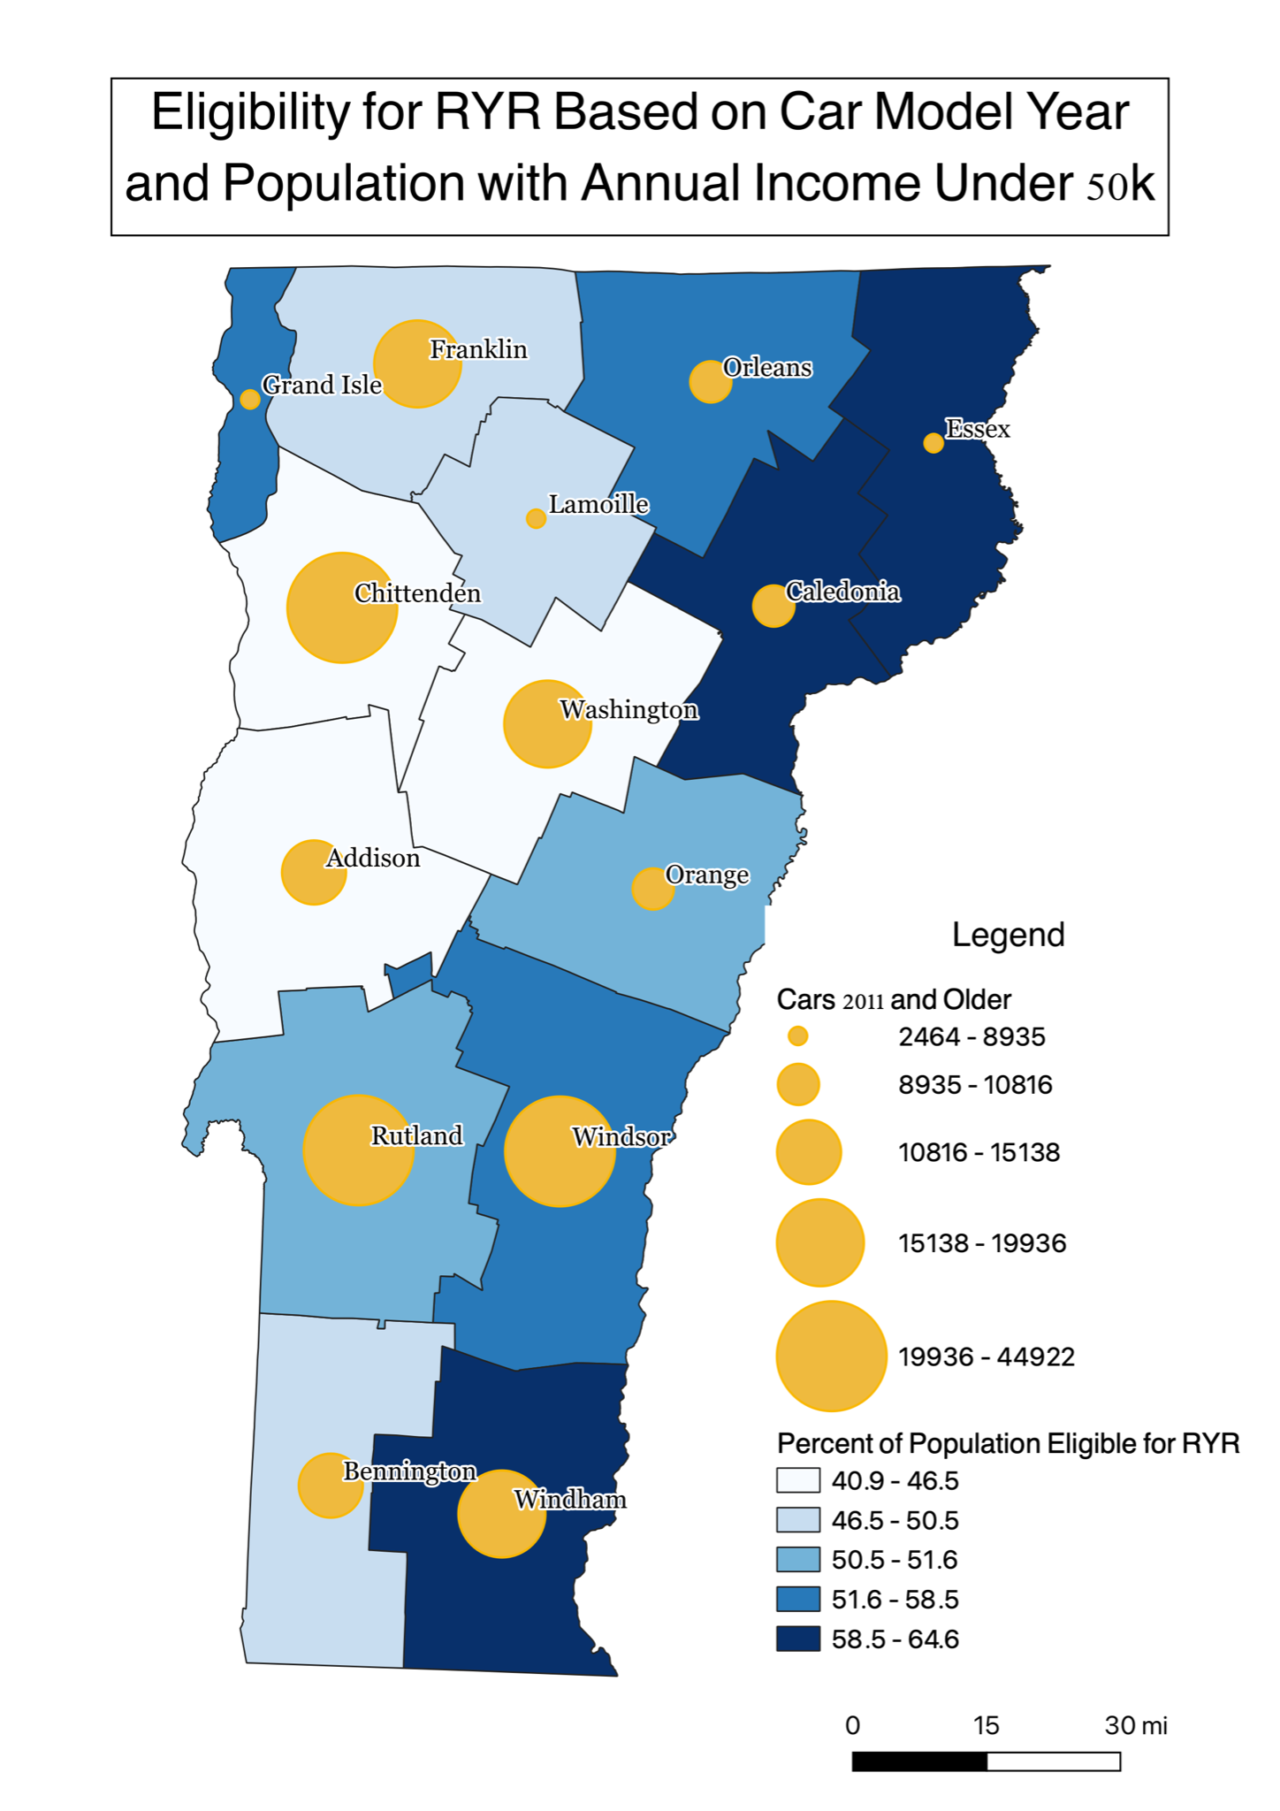
Figure 1: Eligibility for RYR Based on Car Model Year and Population with Annual Income Under 50k
This map represents the financial and vehicular requirements needed to be eligible for Replace Your Ride. To be eligible, a household must make less than $50,000 per year and have a gas running car with a model year older than 2010. The only data available was for cars with model years of 2011 and older so this should be taken into account when interpreting the data.

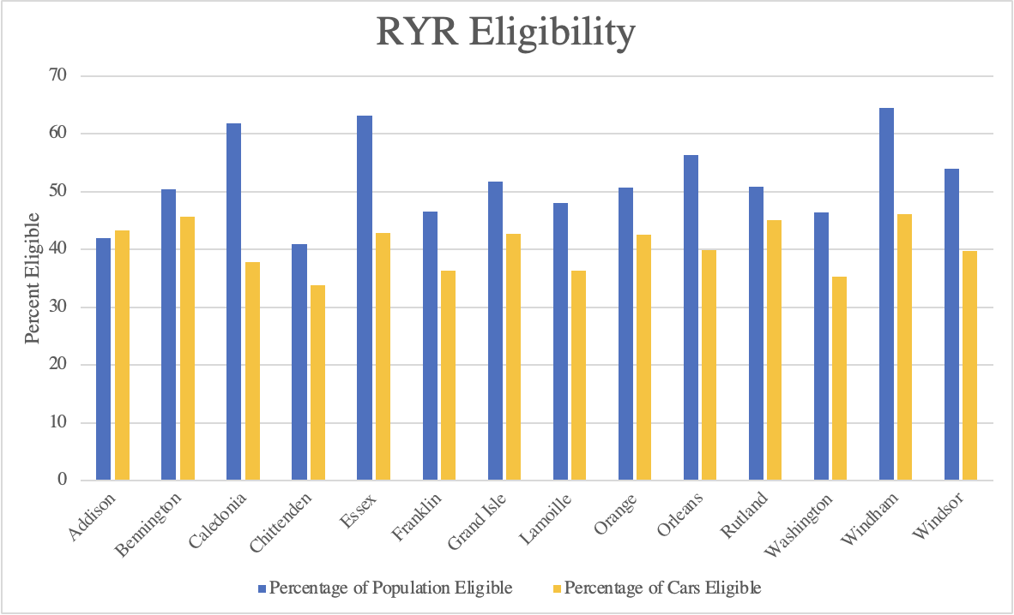
Figure 2: RYR Eligibility
This graph shows the percentage of the Vermont population eligible for RYR and the percentage of cars in Vermont eligible for RYR.

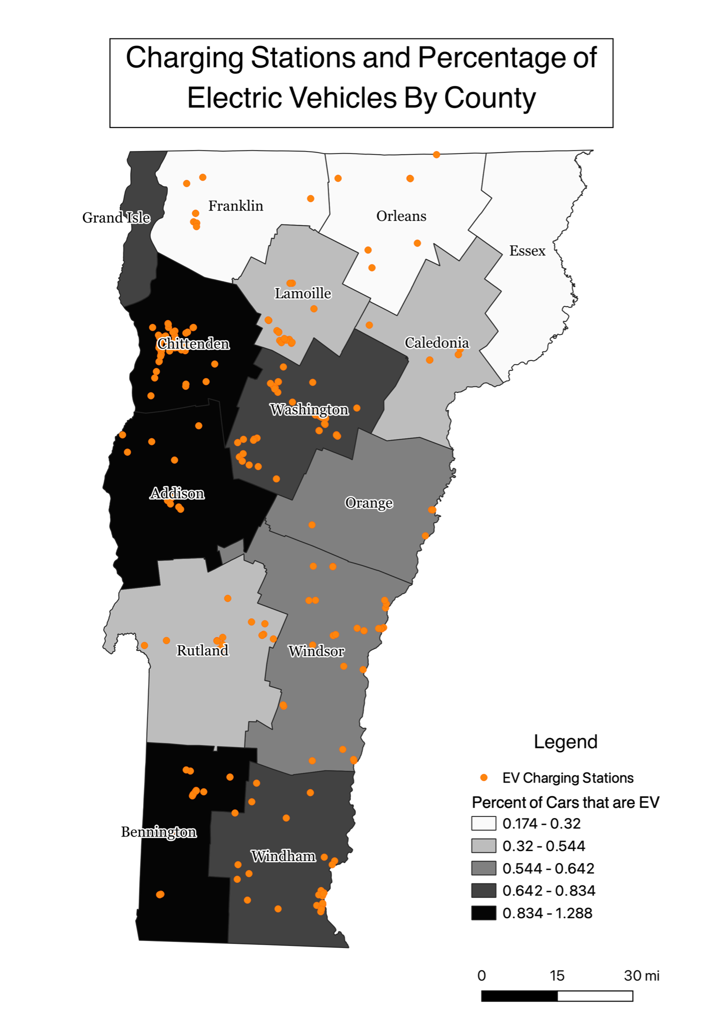
Figure 3: Charging Stations and Percentage of Electric Vehicles By County
This map shows a comparison between charging infrastructure and number of EV’s prior to implementation of RYR. This map can be used to see which counties are good targets for the RYR program that can build on pre-existing infrastructure.
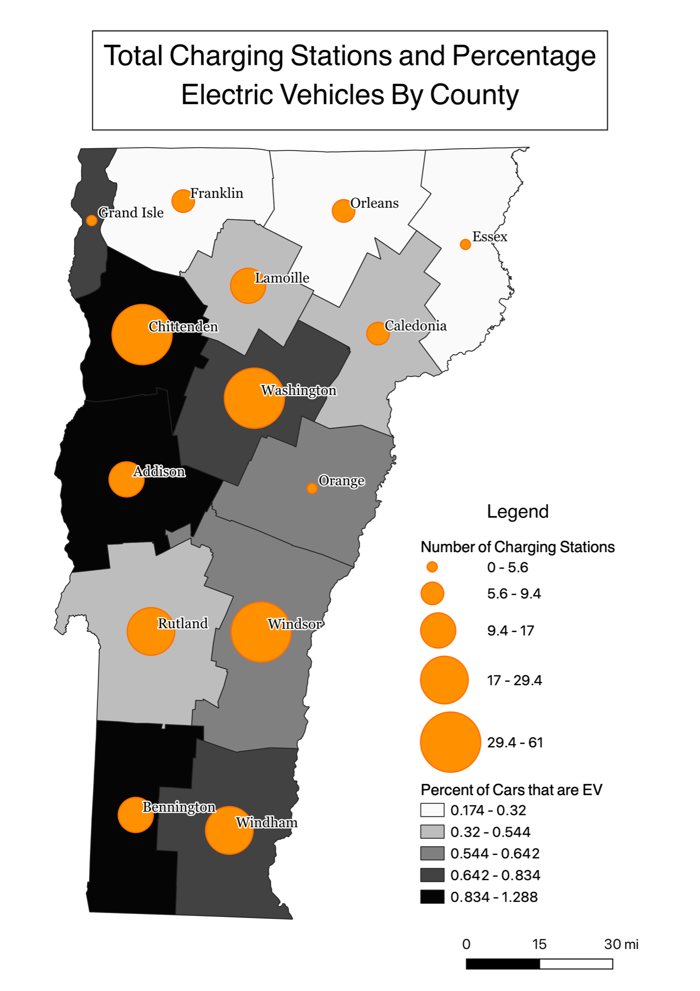
Figure 4: Total Charging Stations and Percentage Electric Vehicles By County
This map shows a comparison between charging infrastructure and number of EV’s prior to implementation of RYR. This map can be used to see which counties are good targets for the RYR program that can build on pre-existing infrastructure.

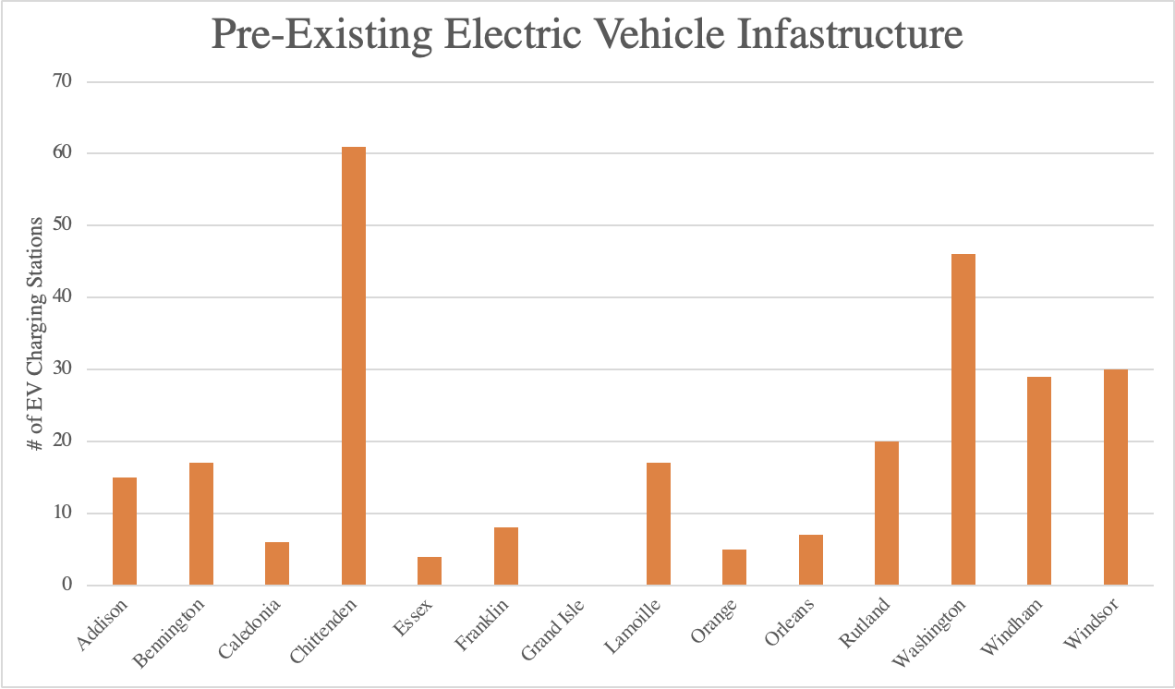
Figure 5: Pre-Existing Electric Vehicle Infrastructure
This graph shows the number of charging stations in each county prior to implementation of RYR. This graph can be used to see which counties are good targets for the RYR program that can build on pre-existing infrastructure.
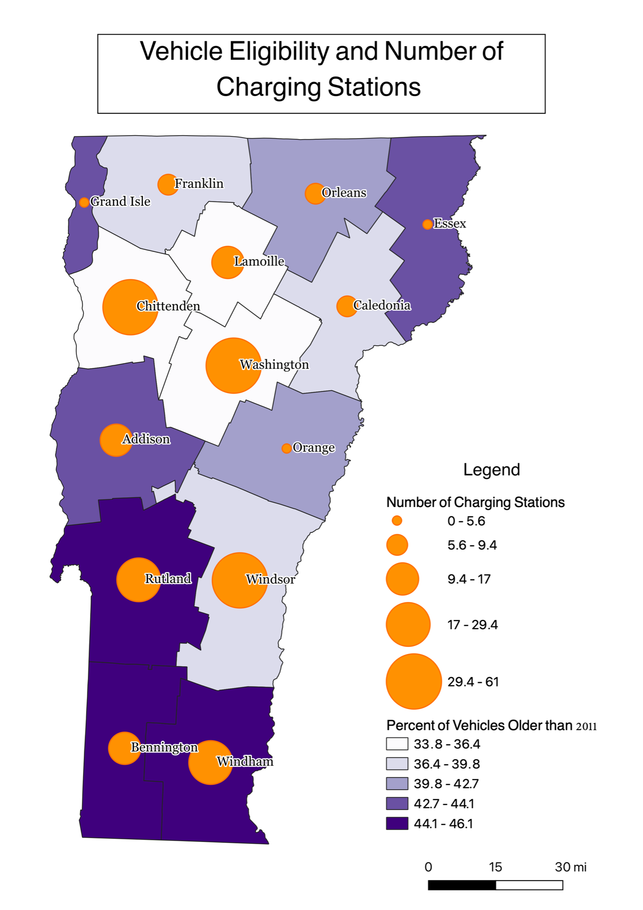
Figure 6: Vehicle Eligibility and Number of Charging Stations
This map represents the percent of vehicles eligible for RYR and how many electric charging stations are available in each county. This is important because it can show how accessible the electric vehicle infrastructure is to people considering purchasing a new electric vehicle.
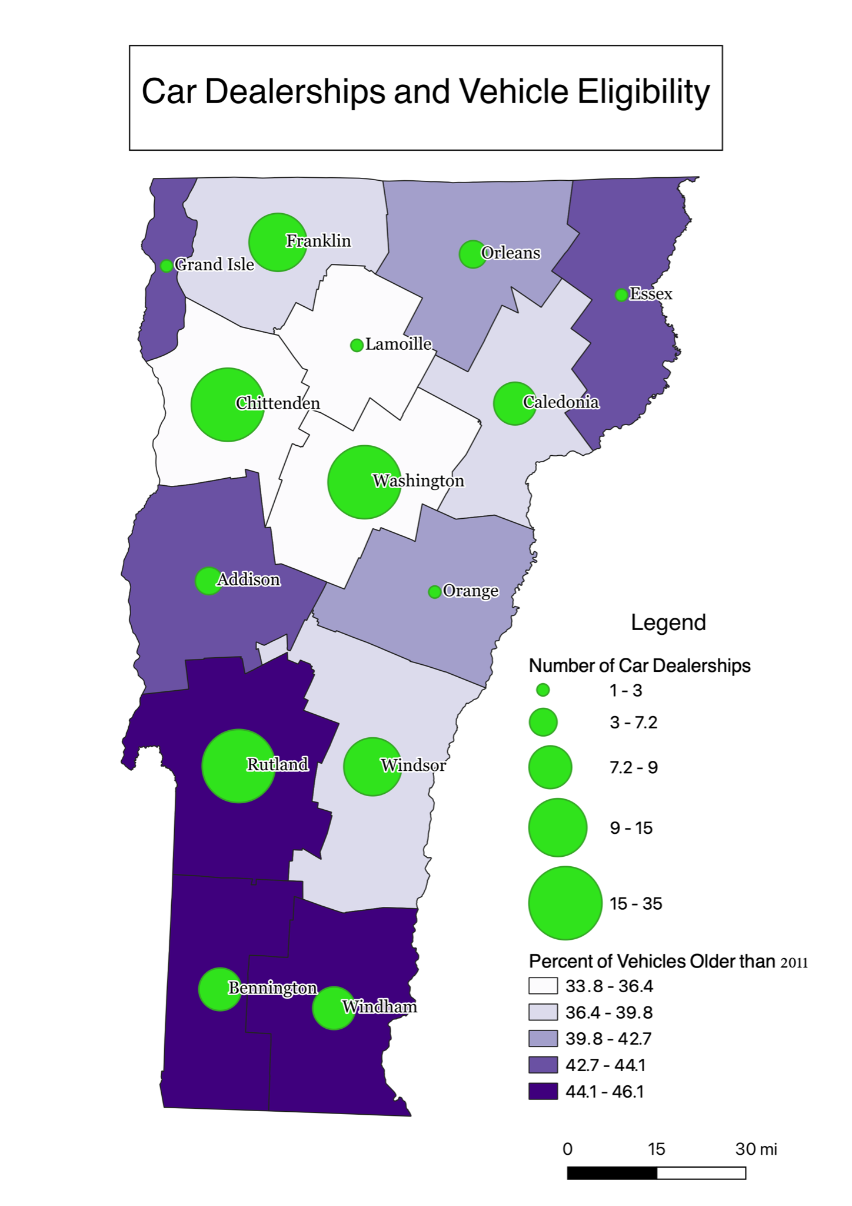

Figure 7: Car Dealerships and Vehicle Eligibility
This map represents the percent of vehicles eligible for RYR and how many dealerships are in each county. This is important because it can show how accessible the electric vehicle dealerships are relative to areas of eligibility.
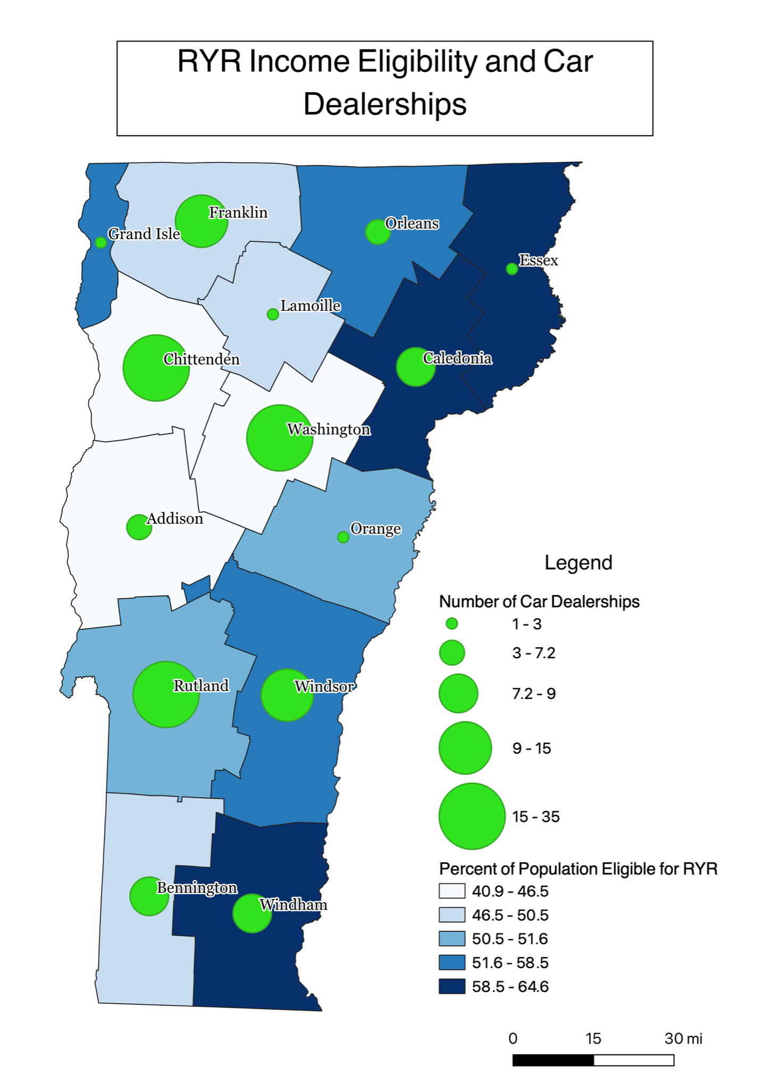

Figure 8: RYR Income Eligibility and Car Dealerships
This map represents the percent of households eligible for RYR and how many dealerships are in each county. This is important because it can show how accessible the electric vehicle dealerships are relative to areas of eligibility.
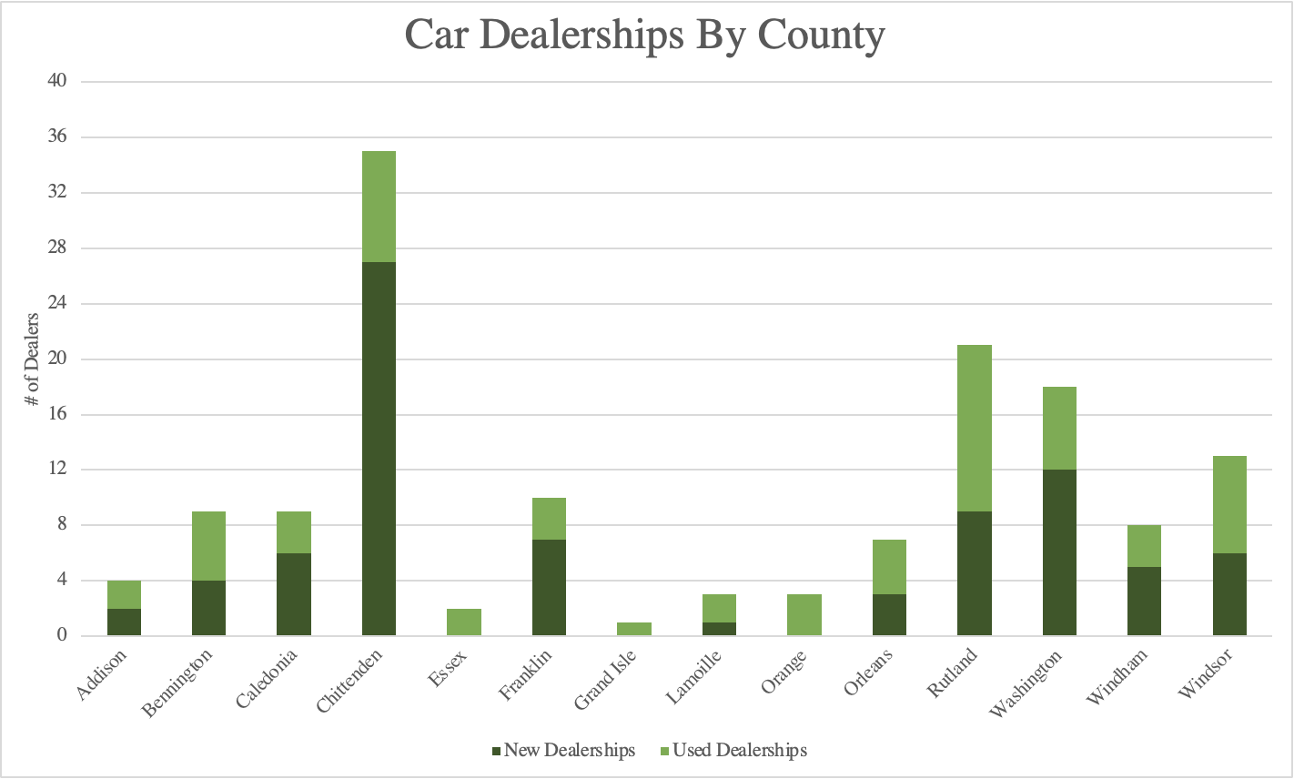
Figure 9: Car Dealerships By County
This graph shows how many dealerships there are in each county. It can tell us how accessible it would be for someone to purchase a new vehicle without leaving the county.

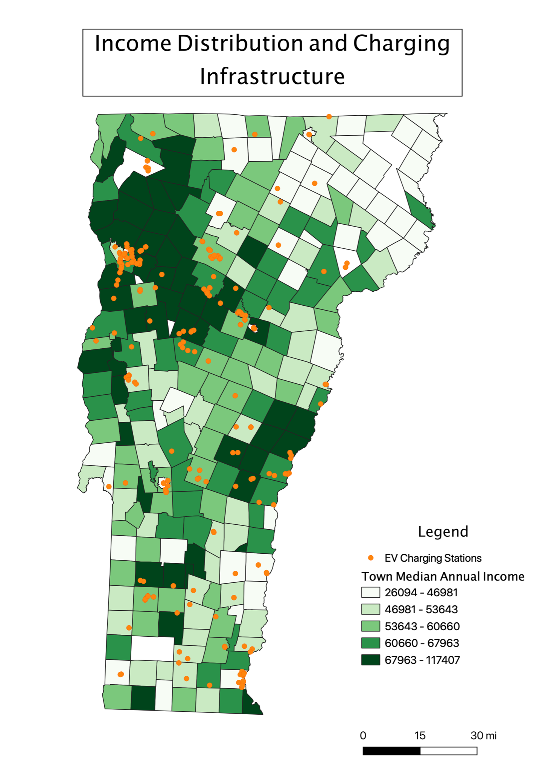
Figure 10: Income Distribution and Charging Infrastructure
This map shows the median annual income and existing EV infrastructure. There are fewer charging stations in low-income areas which is important because the lower income areas will be where the most eligible people are.
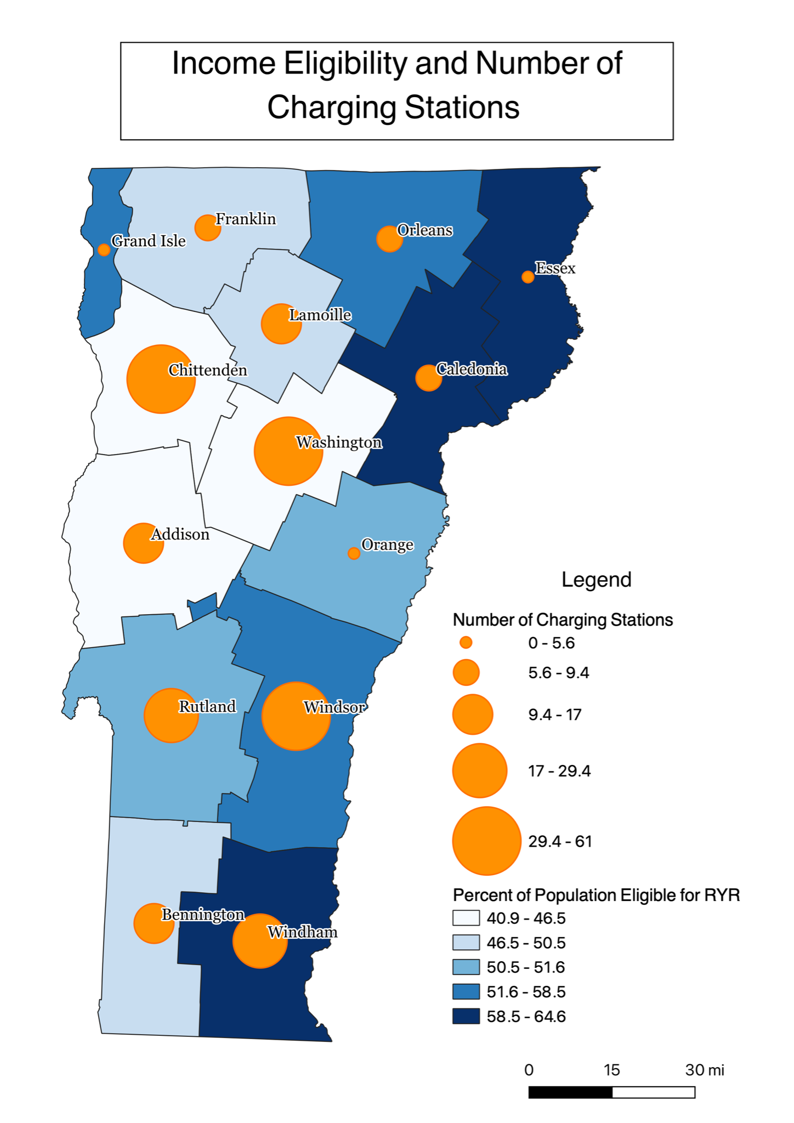

Figure 11: Income Eligibility and Number of Charging Stations
This map shows the most financially eligible counties and existing EV infrastructure. There are fewer charging stations in low-income areas which is important because the lower income areas will be where the most eligible people are.
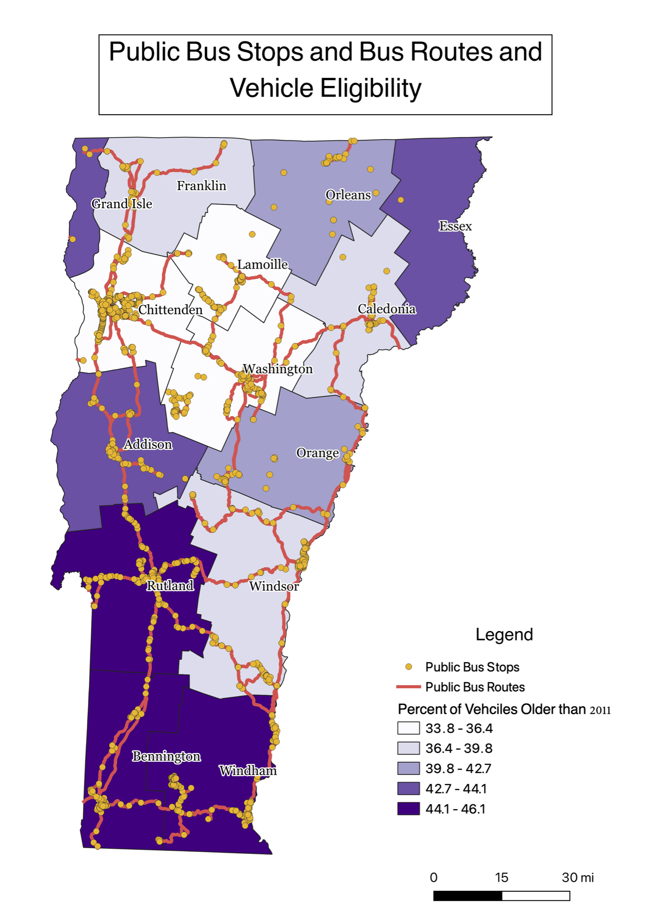

Figure 12: Public Bus Stops and Bus Routes and Vehicle Eligibility
This map shows the bus stops and routes that eligible Vermonter’s can receive a transportation voucher to use.

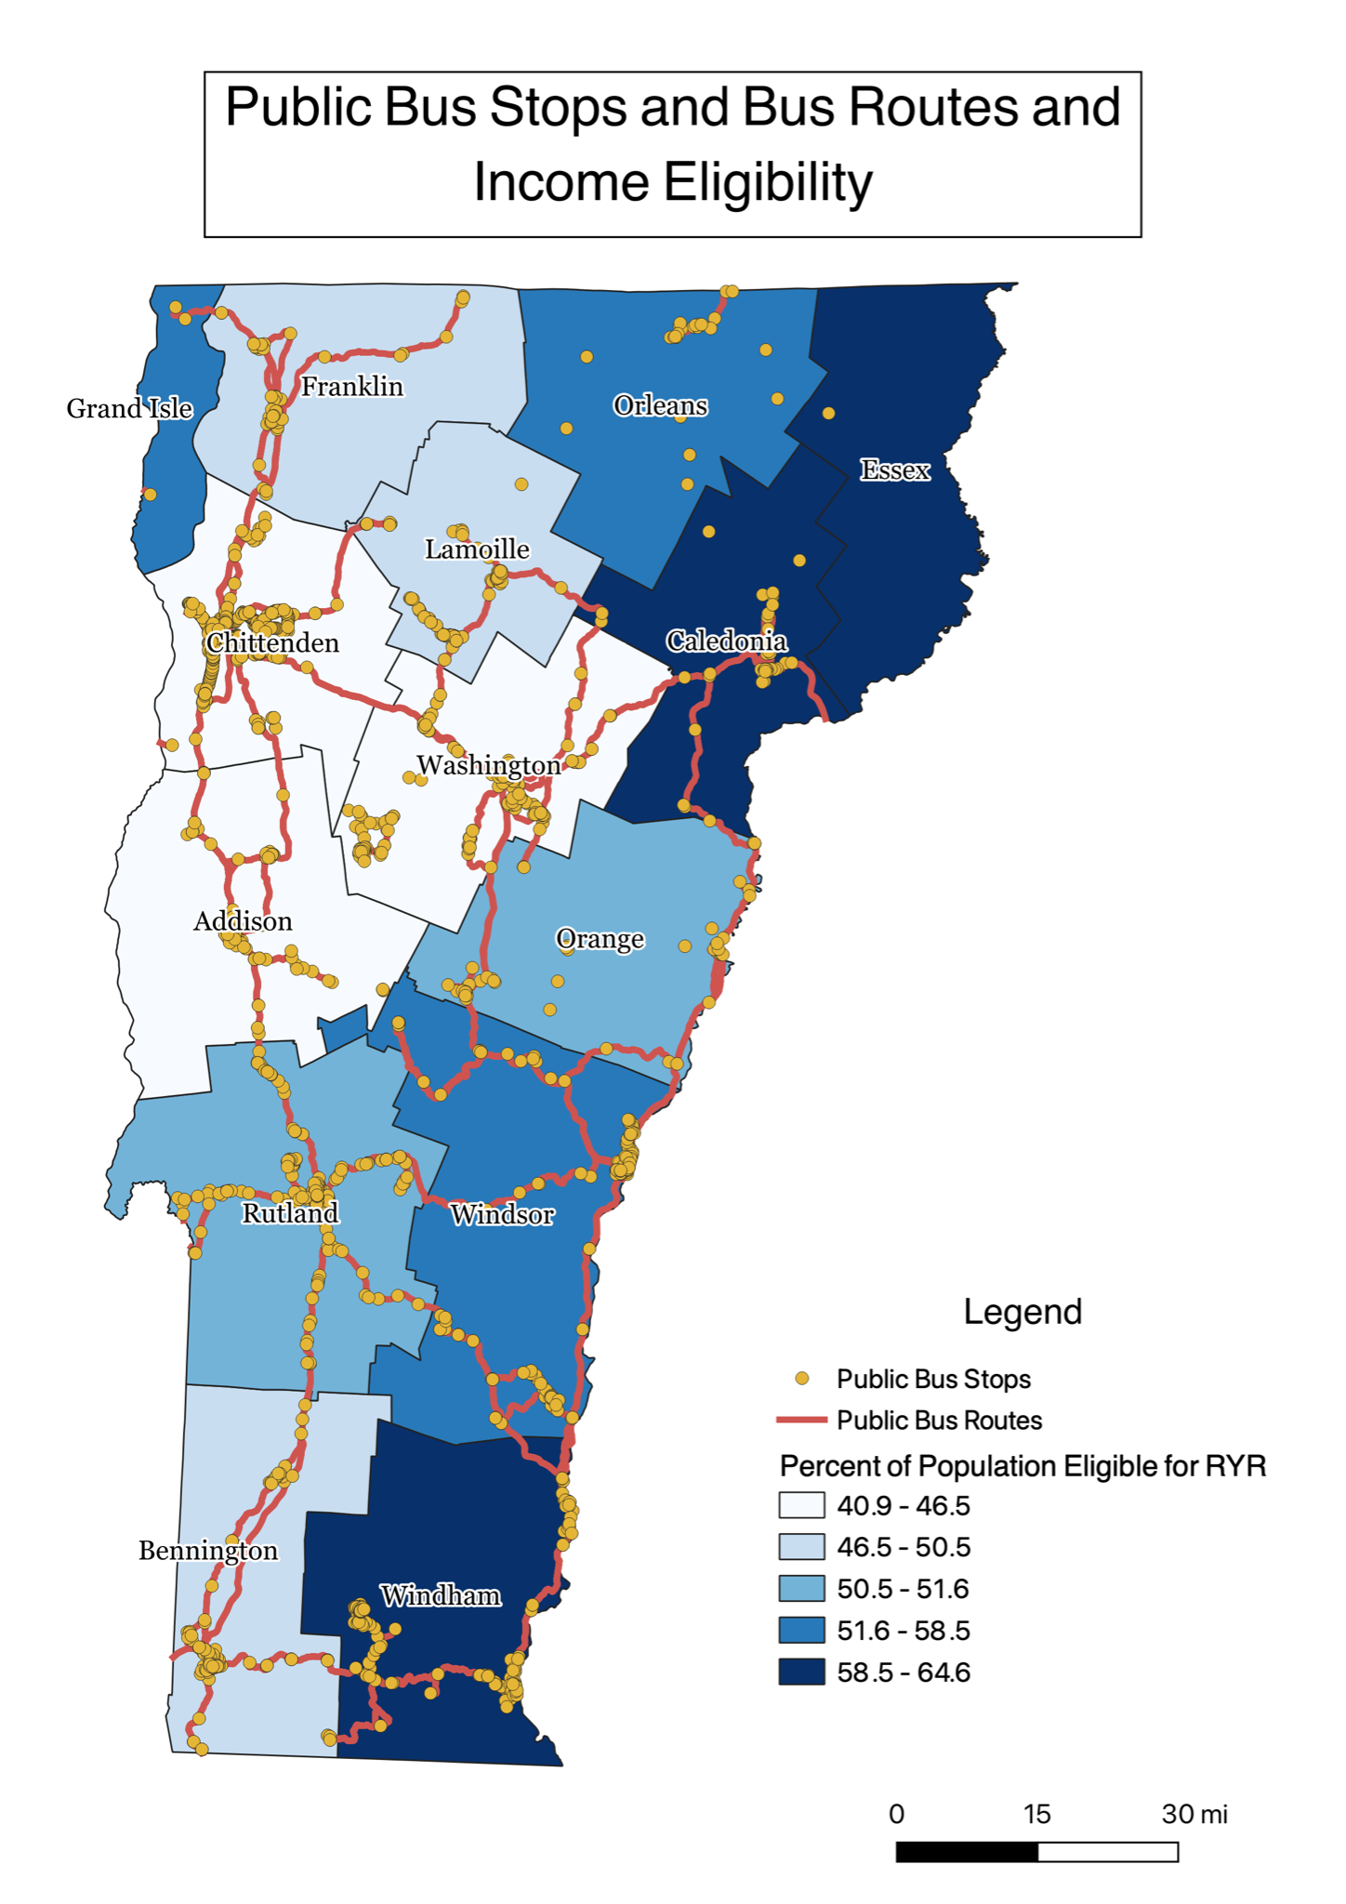
Figure 13: Public Bus Stops and Bus Routes and Income Eligibility
This map shows the bus stops and routes that eligible Vermonter’s can receive a transportation voucher to use. It shows that

Discussion
Our results suggest that Windham and Rutland Counties are good areas to target early implementation of RYR. Both of these counties have a moderate to high percentage of the population that meet the financial eligibility requirements (Fig.1). In addition, both have a high percentage of vehicles that are older than 2011 (Fig.1). This suggests that many people in this area meet the eligibility criteria for RYR. In addition to high eligibility, there is a relatively high amount of existing charging infrastructure in both counties, though especially so in Windham (Fig.4). Contrasted with relatively low numbers of existing electric vehicles, this could suggest potential to support an increase in electric vehicle use through RYR (Fig.4). Both of these counties also have moderately high to high numbers of car dealerships, which could provide locations for program candidates to purchase electric vehicles (Fig.7-9).
In other areas where implementation of RYR is most feasible due to the presence of charging infrastructure, like Chittenden and Washington Counties, there is a lower percentage of the population that is financially eligible (Fig.11). In addition, these counties, along with Addison, have relatively high percentages of electric vehicles already being used (Fig.4). That being said, these counties have some of the highest concentrations of charging infrastructure and car dealerships, and therefore implementation is highly achievable (Fig.6-7).
Furthermore, counties like Essex, Caledonia, Grand Isle, and Orleans have high populations of eligible people but lack infrastructure (Fig.11). In areas like these, building more accessible infrastructure like public charging stations could help increase numbers of electric vehicles.
Lastly, those who may not be able to afford a new or used electric vehicle are still eligible for replace your ride benefits. They are able to receive a transportation voucher to use for the public bus system. Data shows that bus stops are concentrated in more populated and urban areas like Rutland and Chittenden counties. In Rutland county, there is a high concentration of public transportation and a high percentage of vehicles older than 2011. If people in Rutland county are to trade in their old vehicles, public transportation may be a viable option (Fig, 12). Counties in northeastern Vermont like Essex and Orleans are isolated and cut off from the public transit systems (Fig.12-13). This suggests that work can be done to make public transportation more accessible to all areas in all counties. It is notable that throughout our research we found a significant lack in bike infrastructure data, which suggests that improvements are needed in this area, along with more accessible information on bike routes.

Outreach

Car Dealership Phone Survey

Methods
For our car dealership phone survey, we reached out to 60 used dealerships and 66 new dealerships. We were able to speak with 34 and 40 respectively; those who we did not speak with either had bad connection, were too busy or did not want to talk, were no longer operating, or were not relevant to the study (tractor-trailers, auto repair shops, boat dealers, etc.). Before we began calling new and used dealerships, we collaborated with the RYR team on a script to use during the calls, which can be found in Appendix B. As we continued to cold-call dealerships, we realized some strategies worked better than others. For instance, we noticed it was better to call in the morning, usually between 9 and 10am, or in the late afternoon close to 5pm, when salesmen were less likely to be with a customer. In addition, we had originally introduced ourselves as Middlebury students doing research on electrical vehicle sales in Vermont. However, sometimes upon hearing the word “electric”, dealers would inform us that they didn’t carry any and hung up immediately. Therefore, from then on, we would introduce ourselves as researching “vehicle” sales in Vermont.
After each call, we would input relevant information into a spreadsheet with various categories. Once we finished all the calls, we went through the spreadsheet and cleaned it up, moving all notes to the end and making sure each section had the same format so that we would have clear categories with which to make visualizations. We have created a series of bar graphs and pie charts which can be found below.

Results

Used Car Dealerships
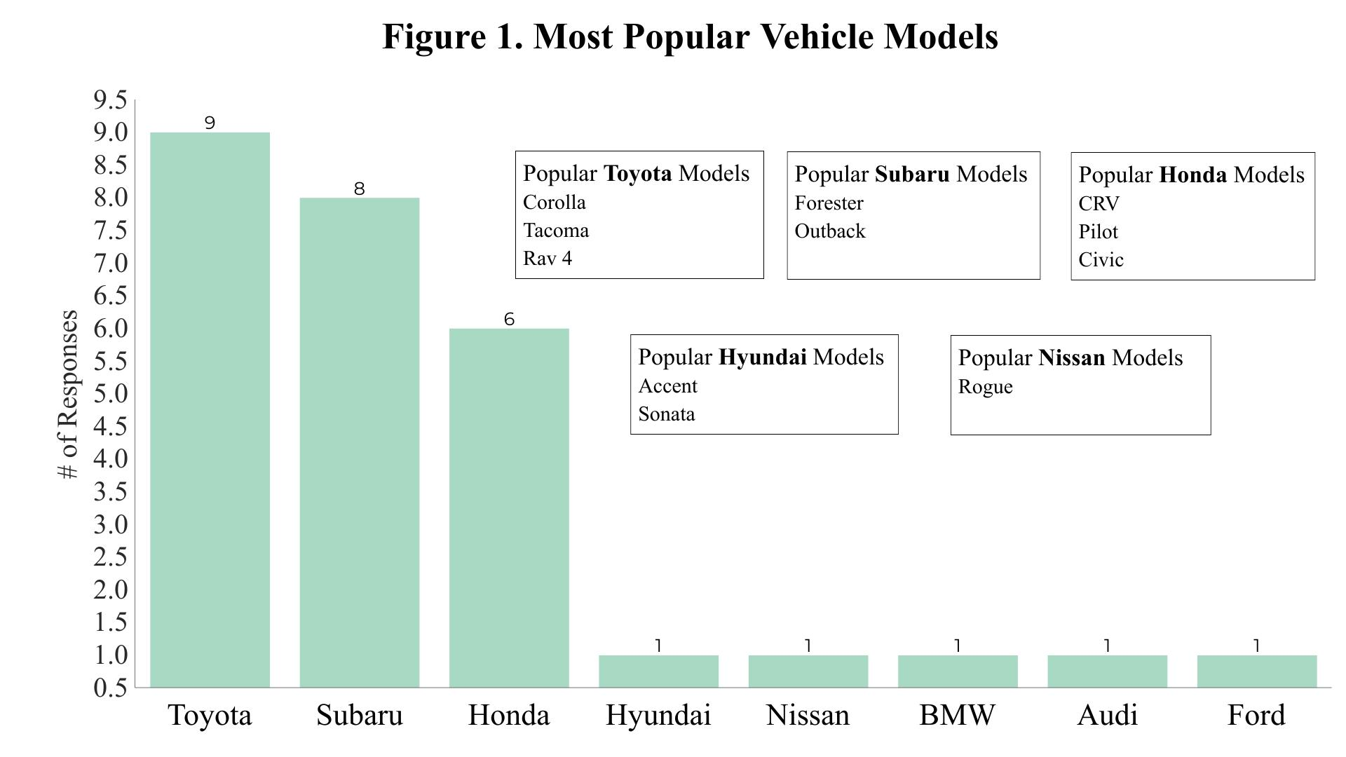
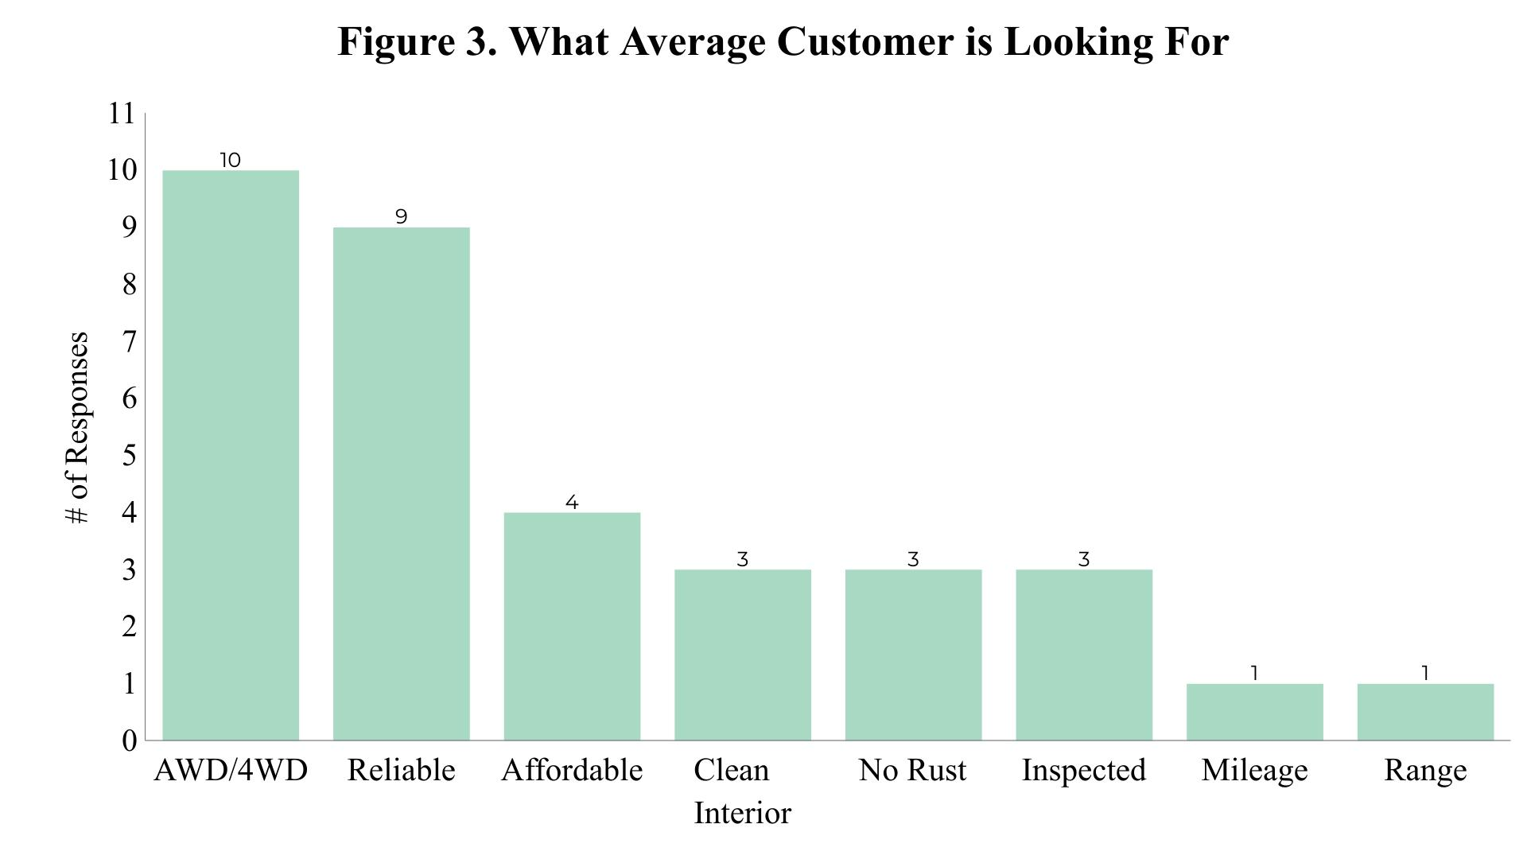
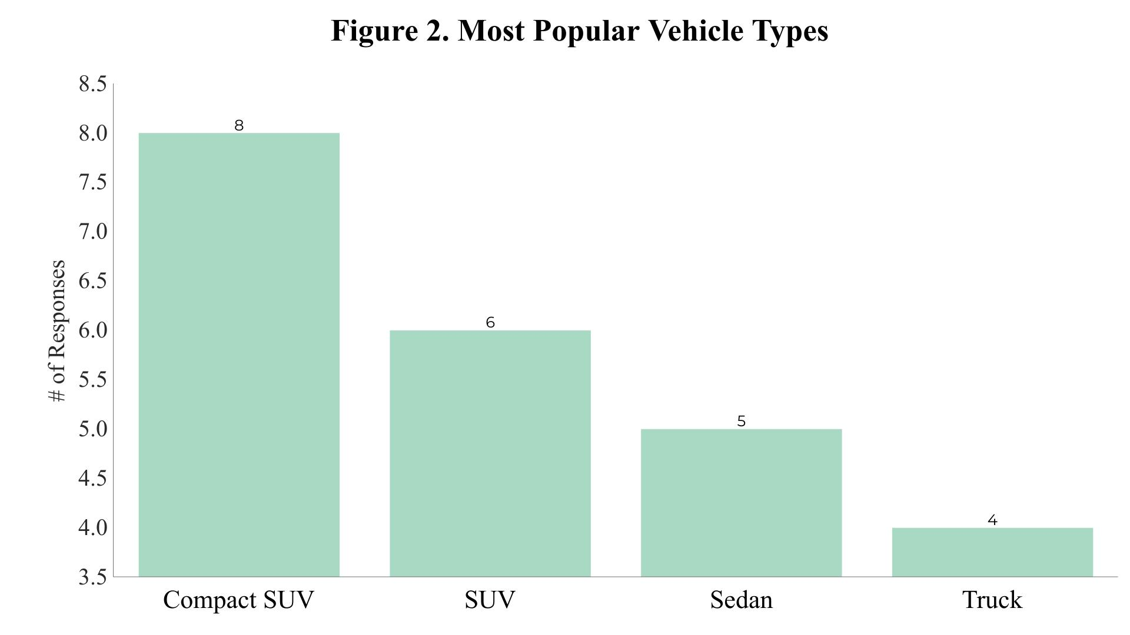
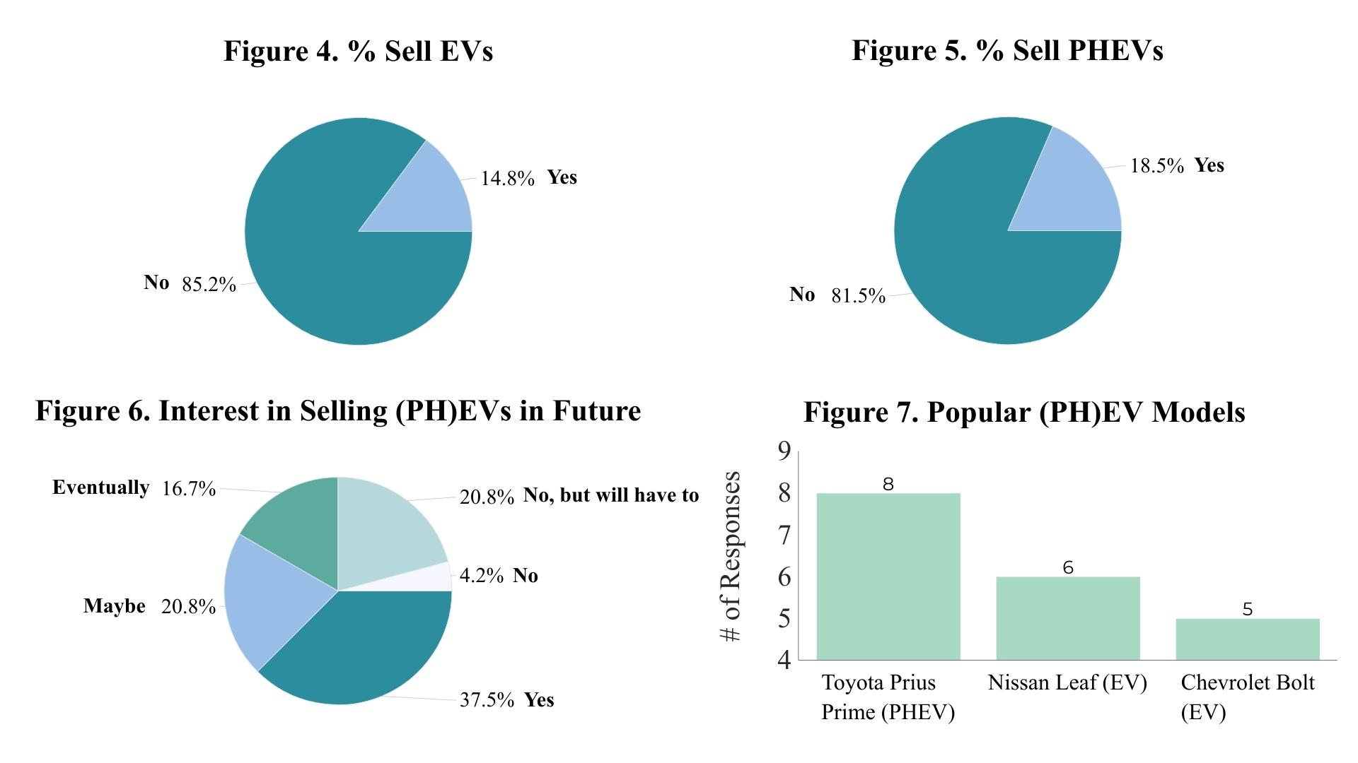
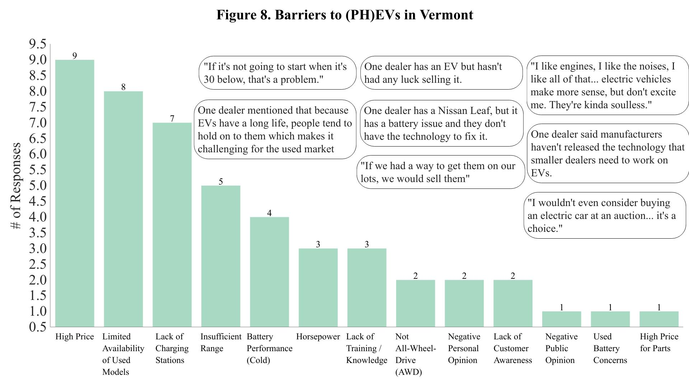
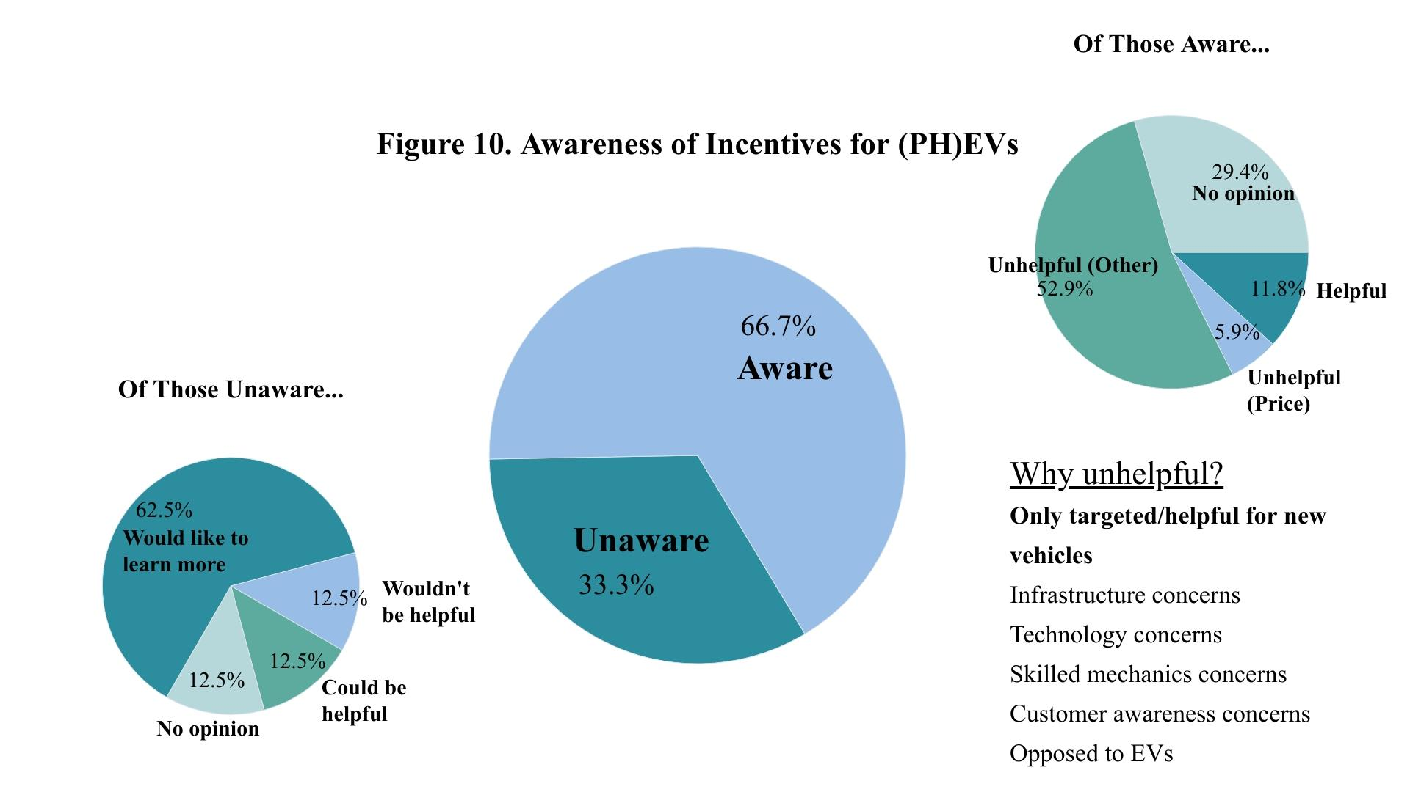
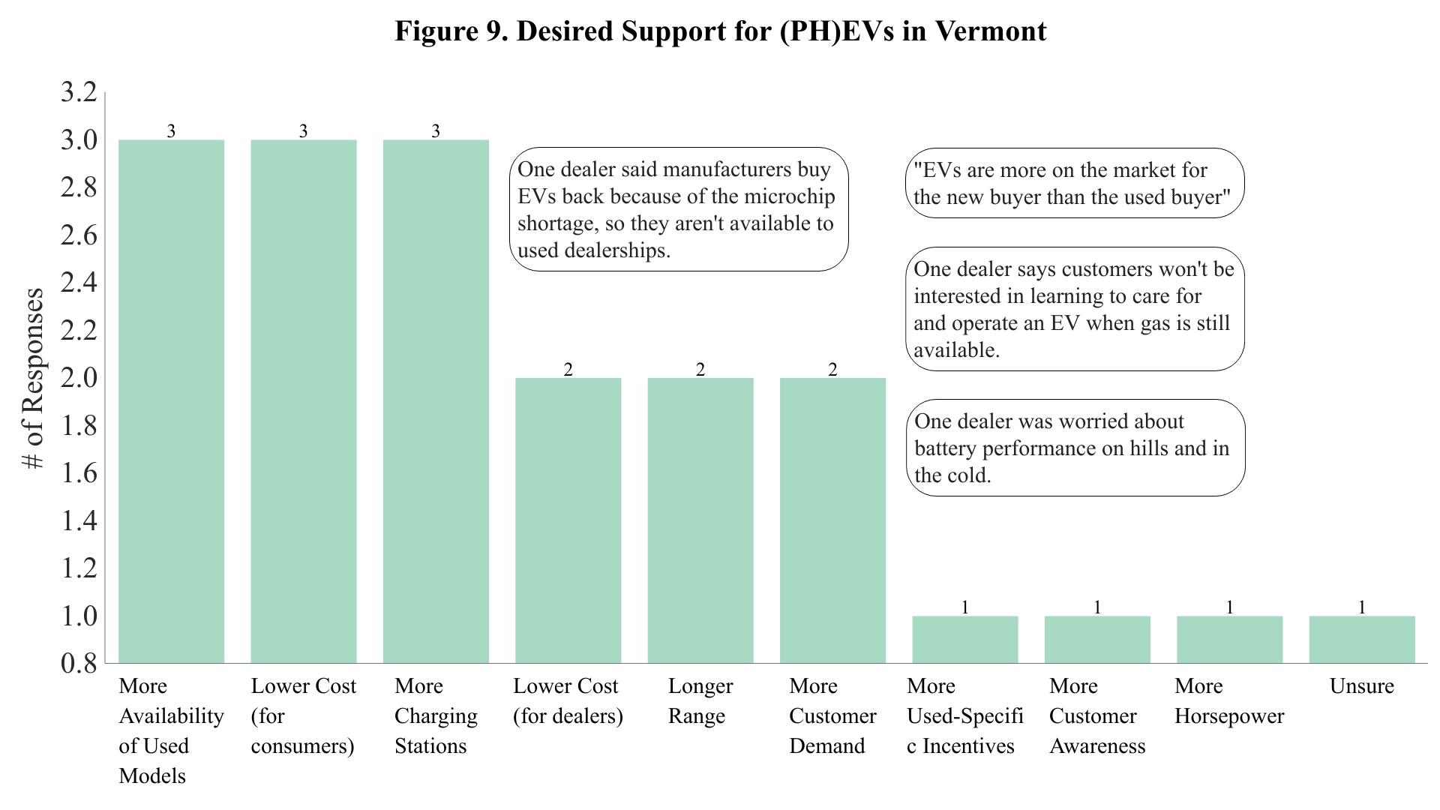

New Car Dealerships
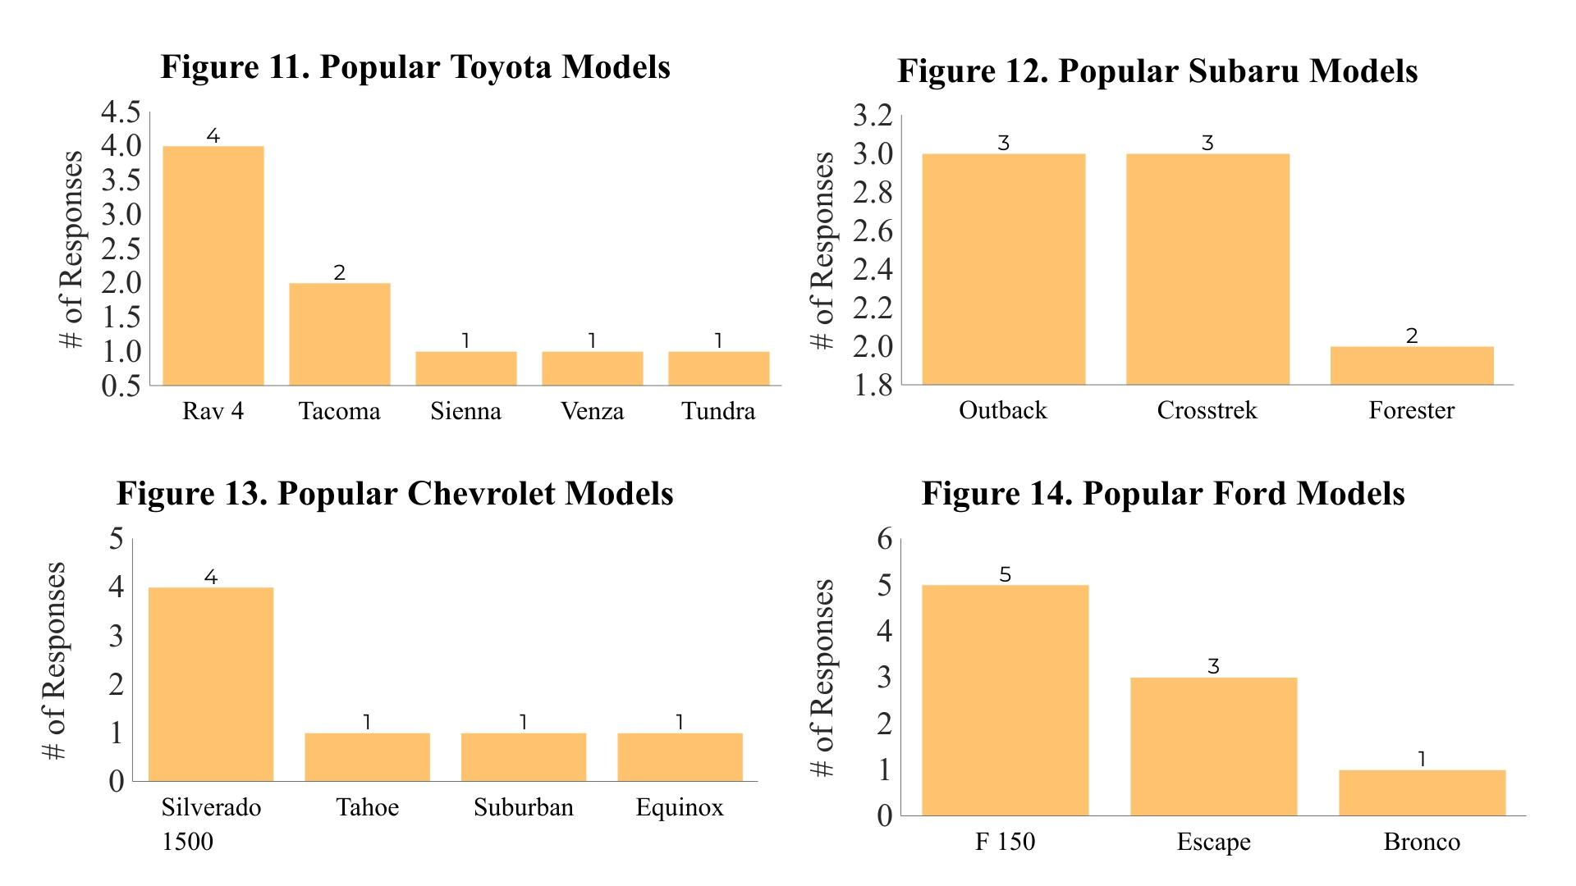
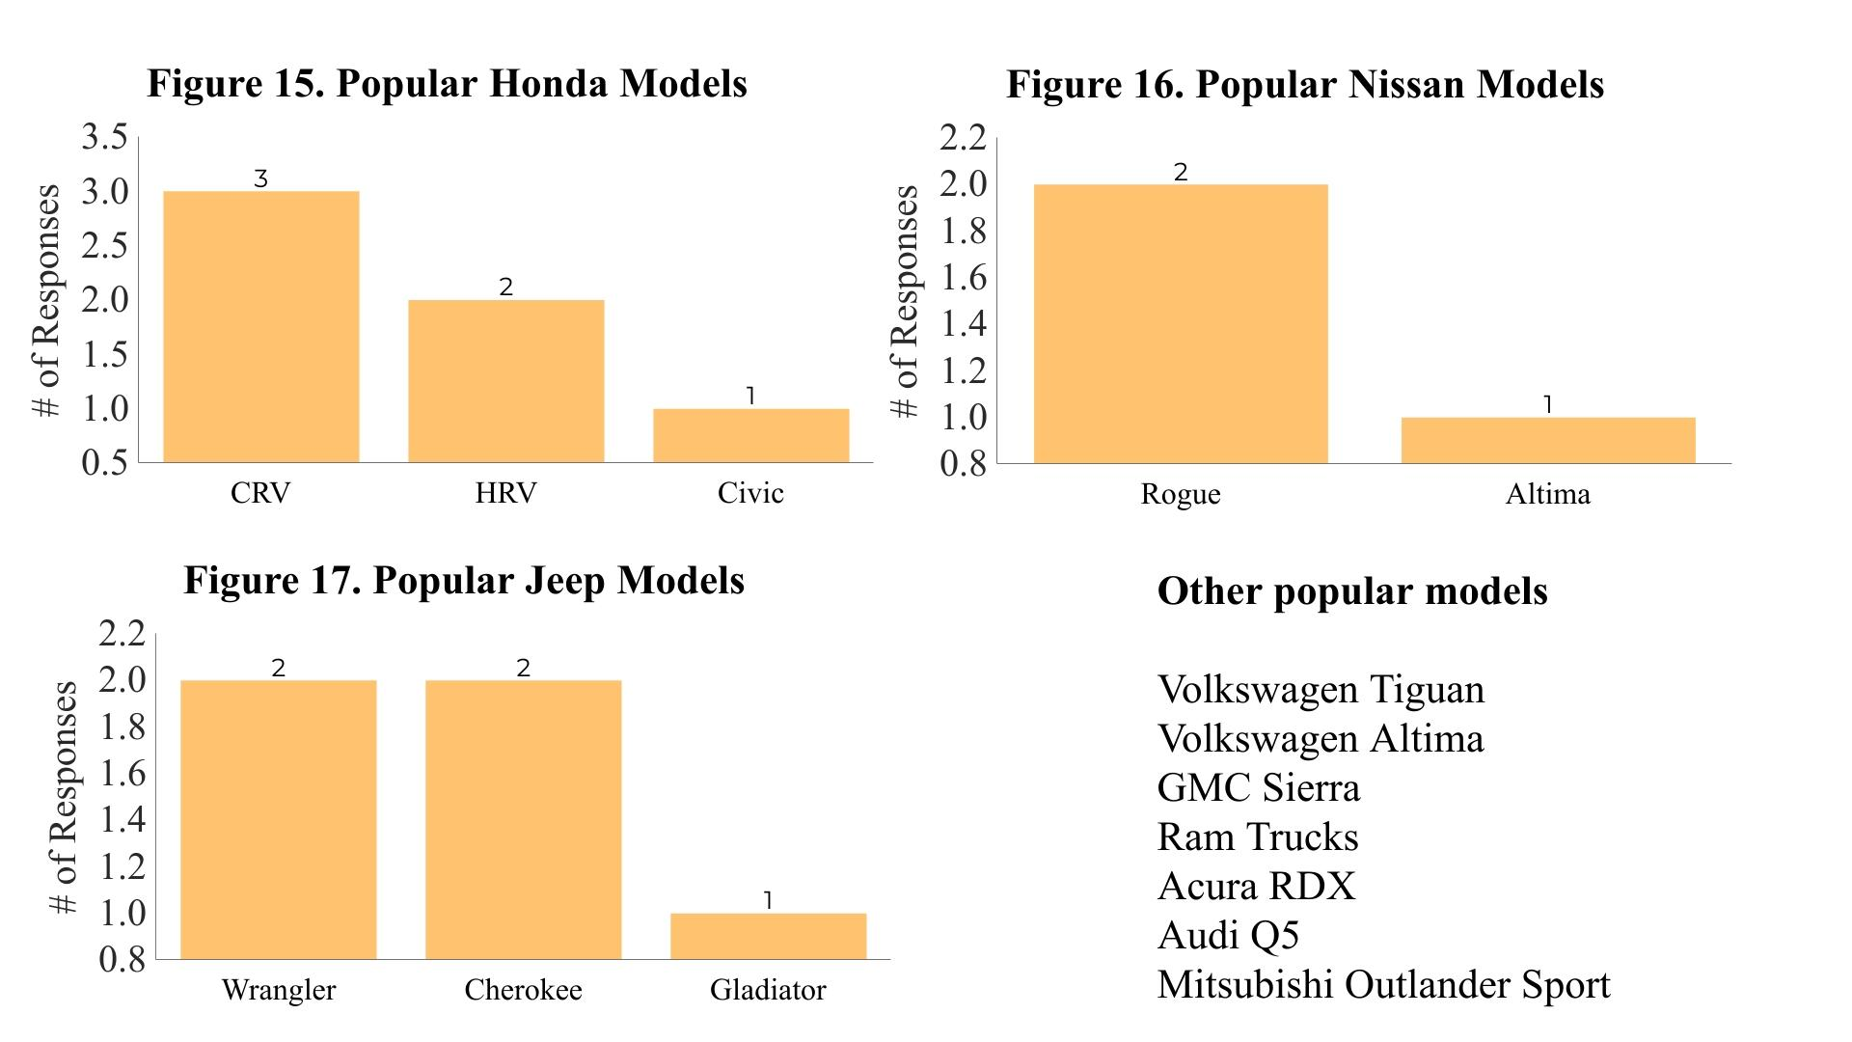
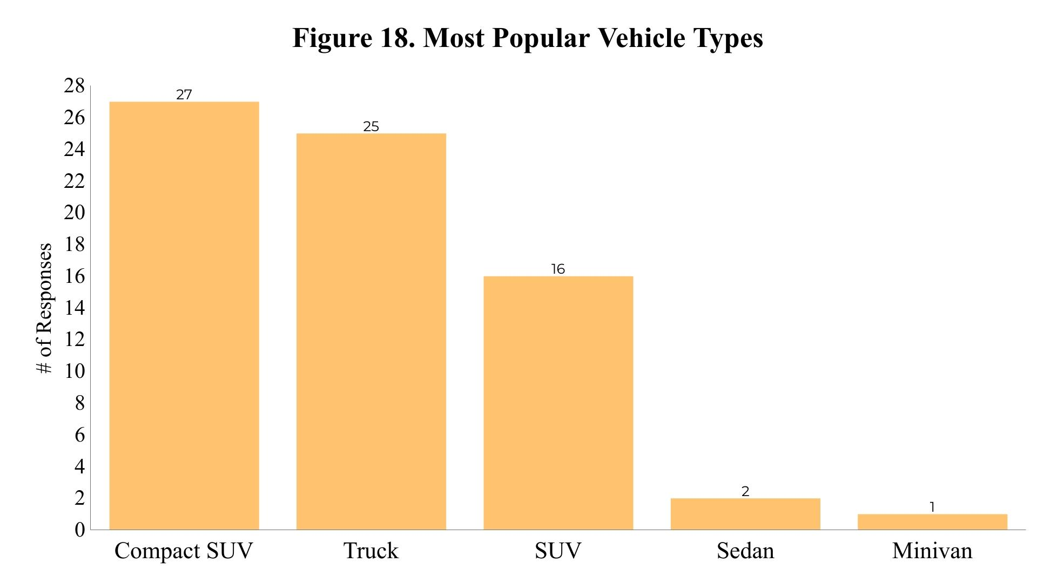
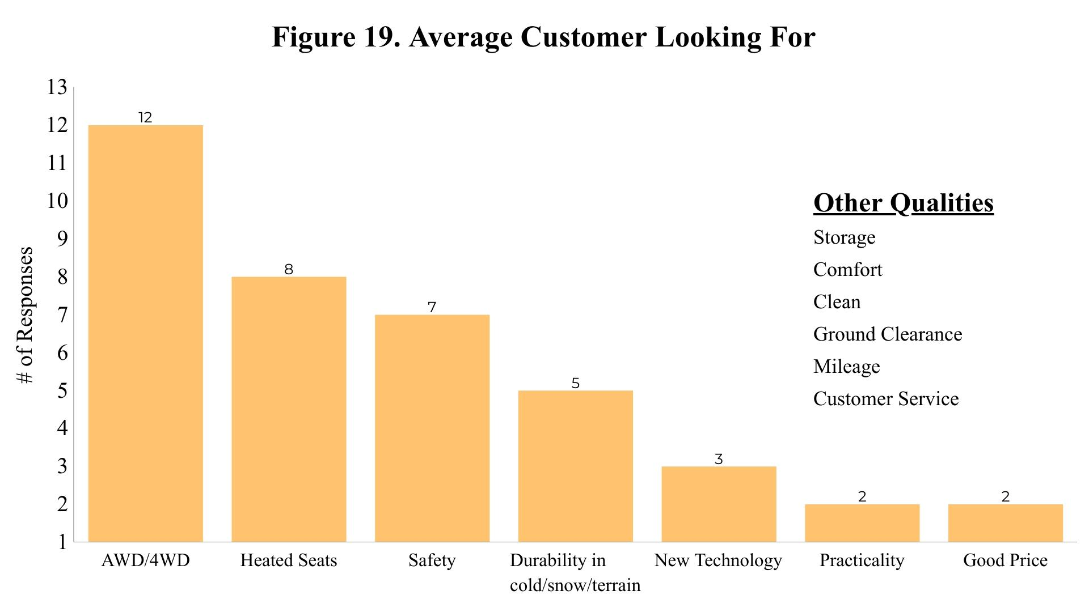
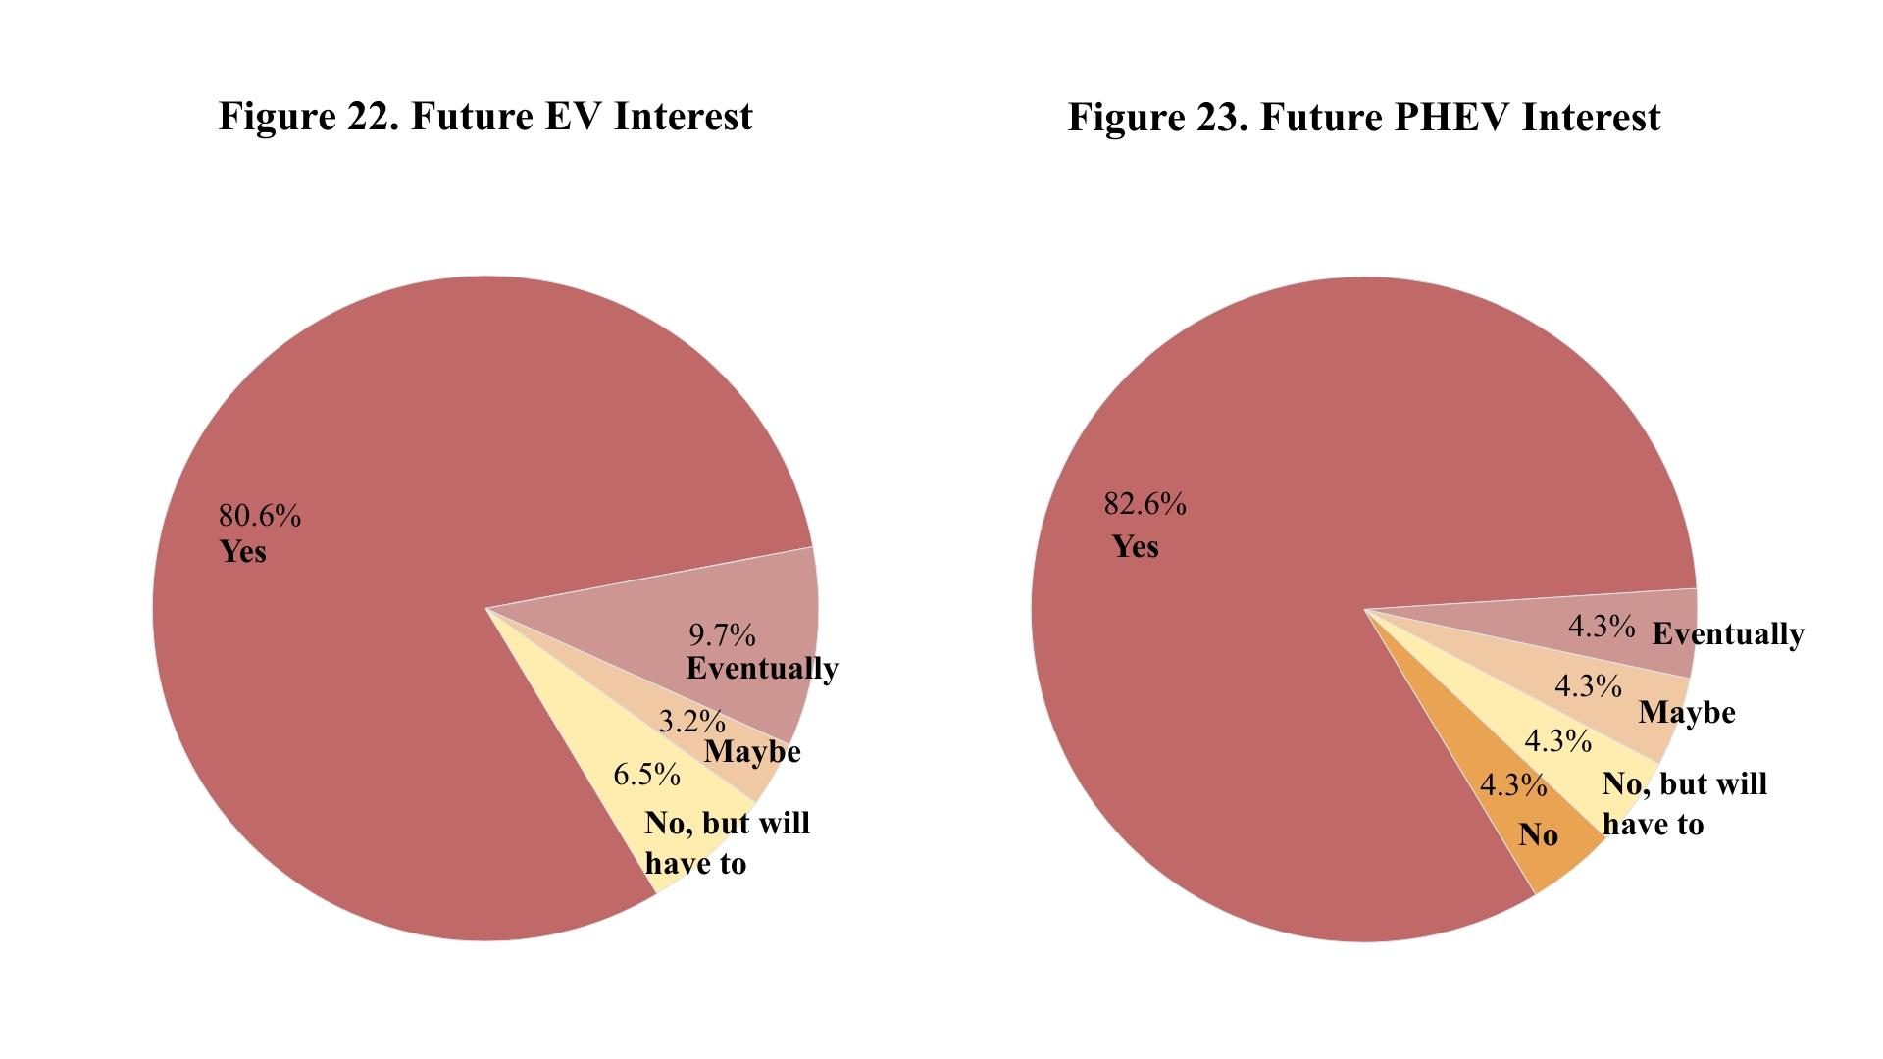
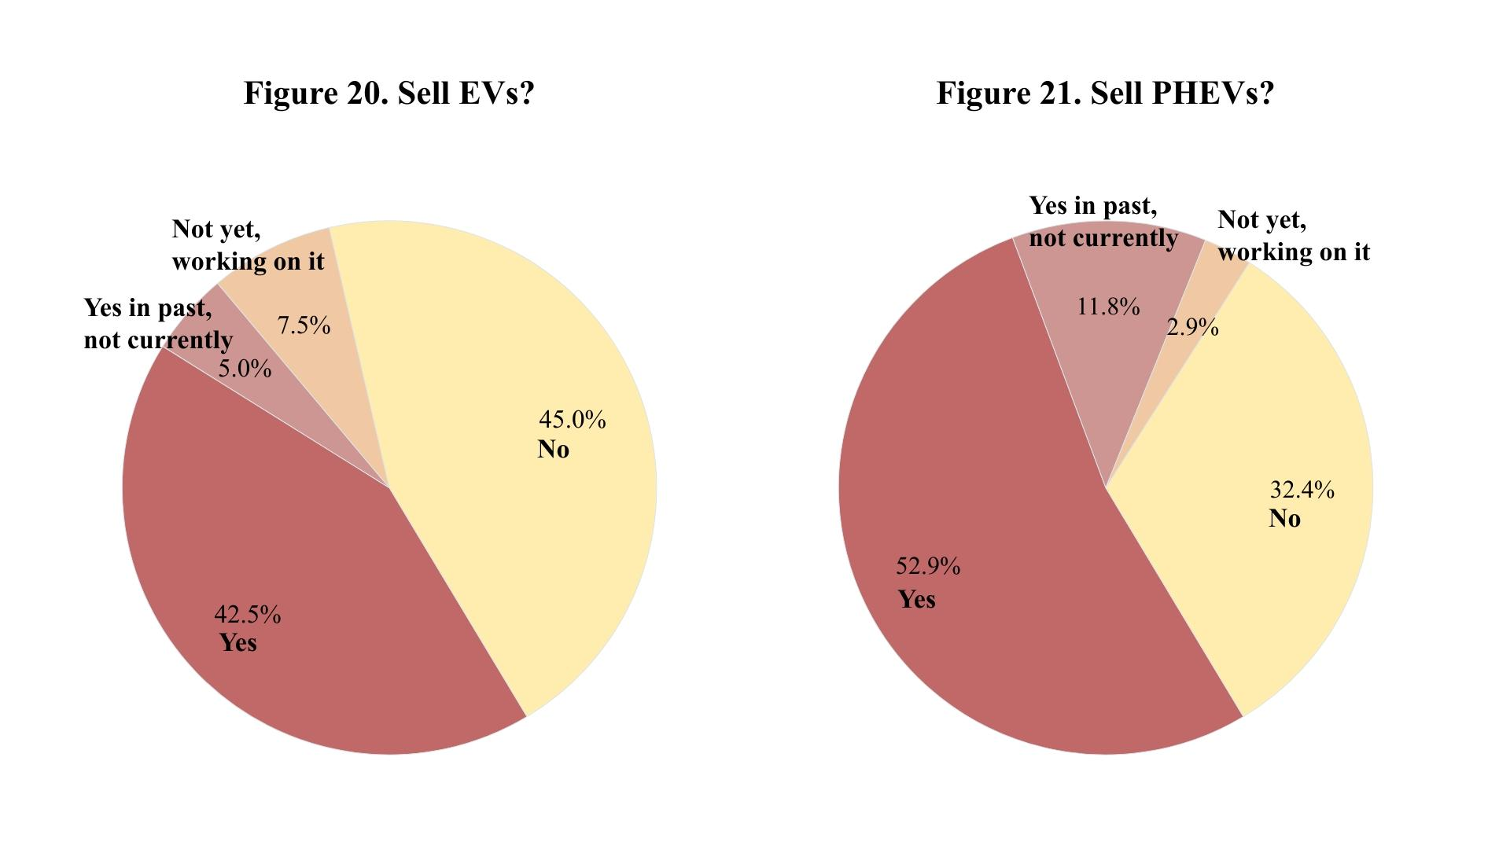
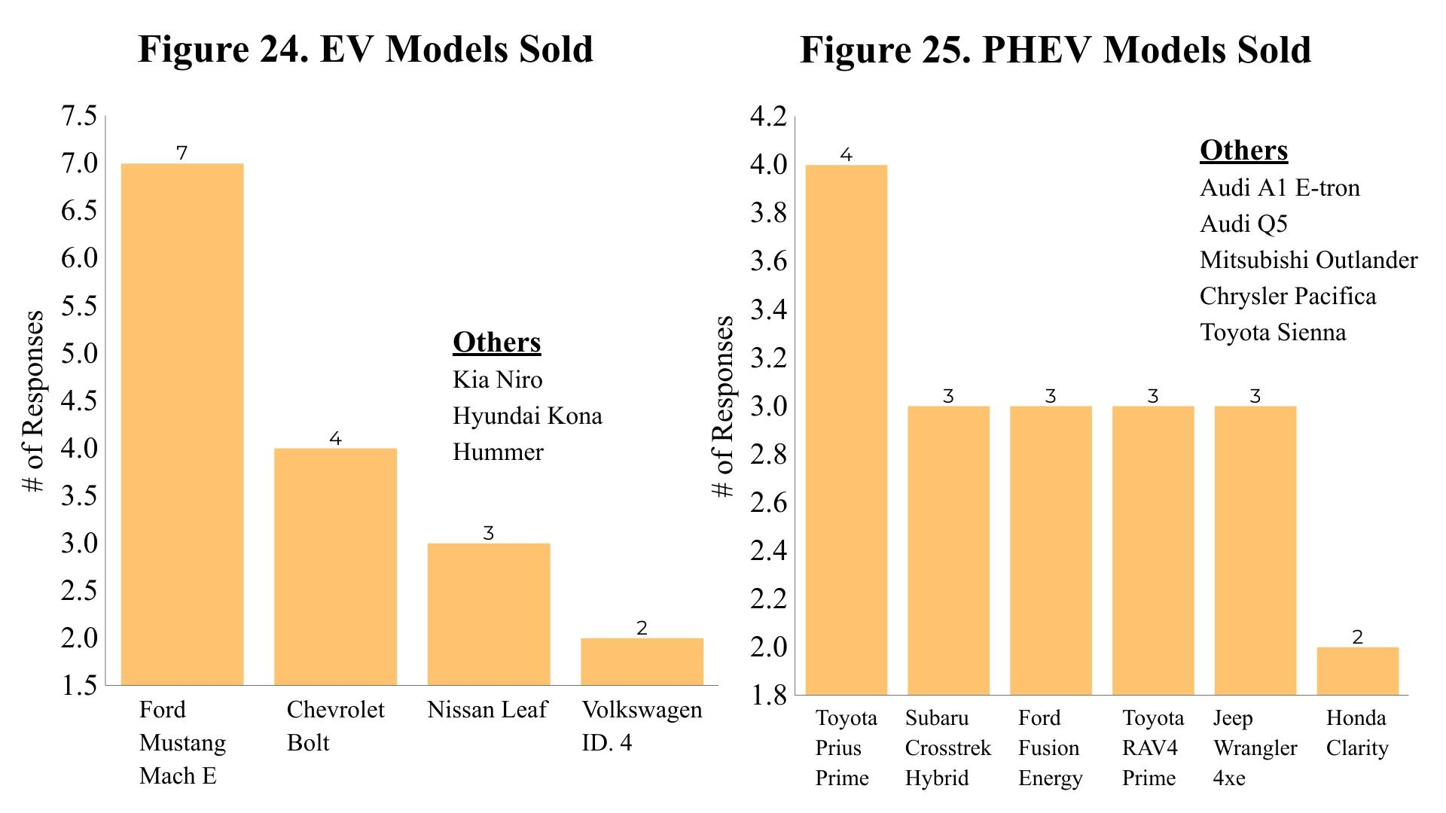
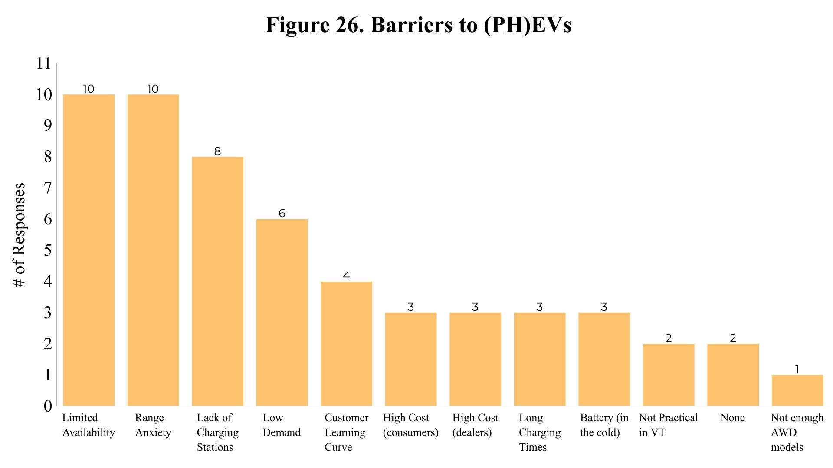
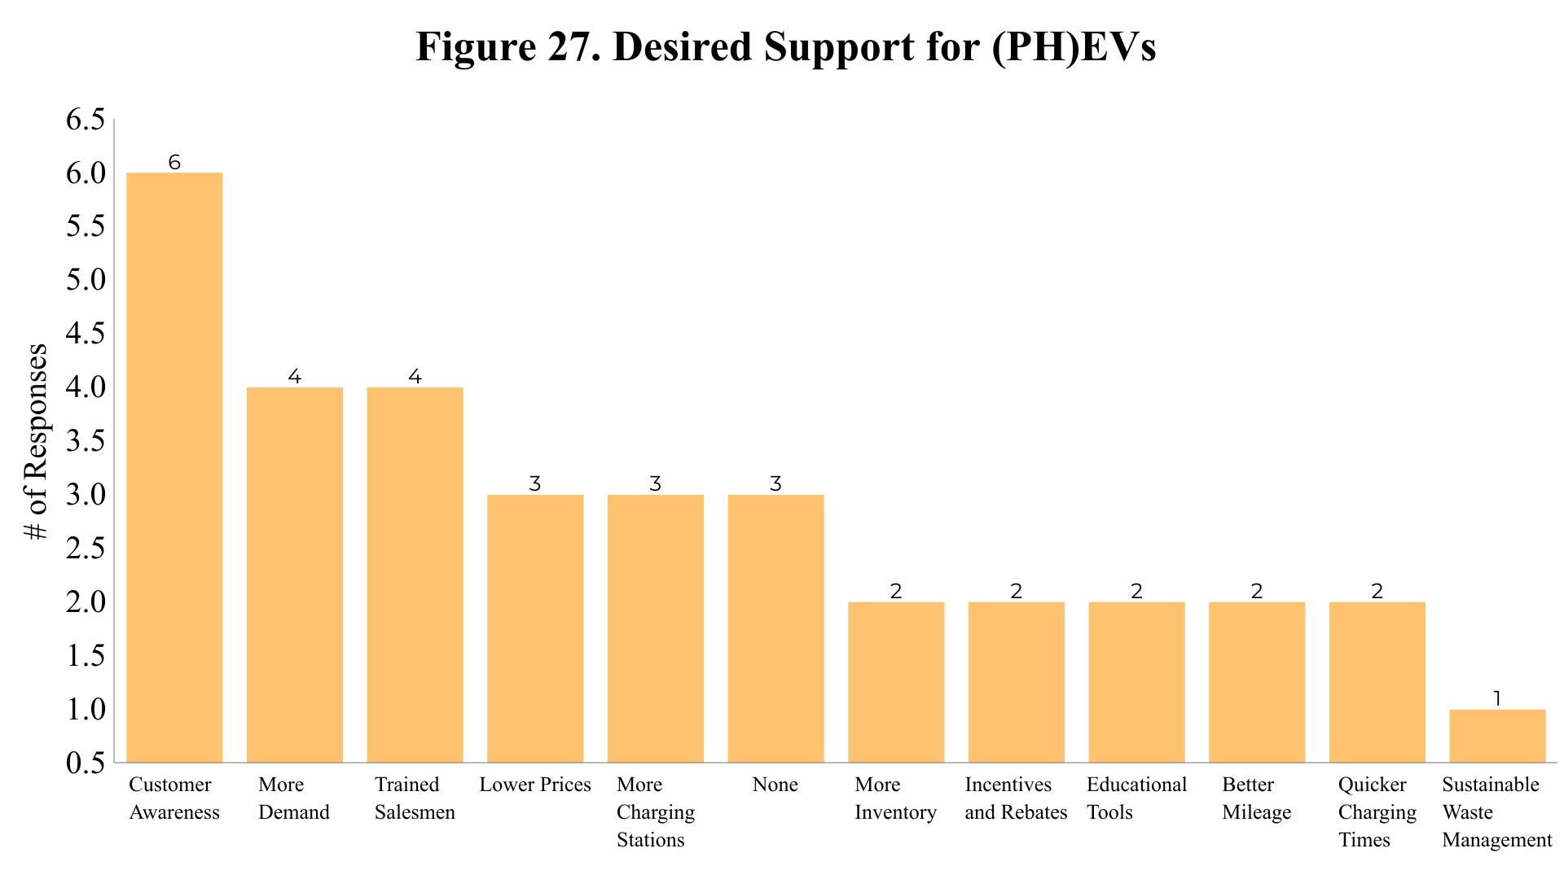
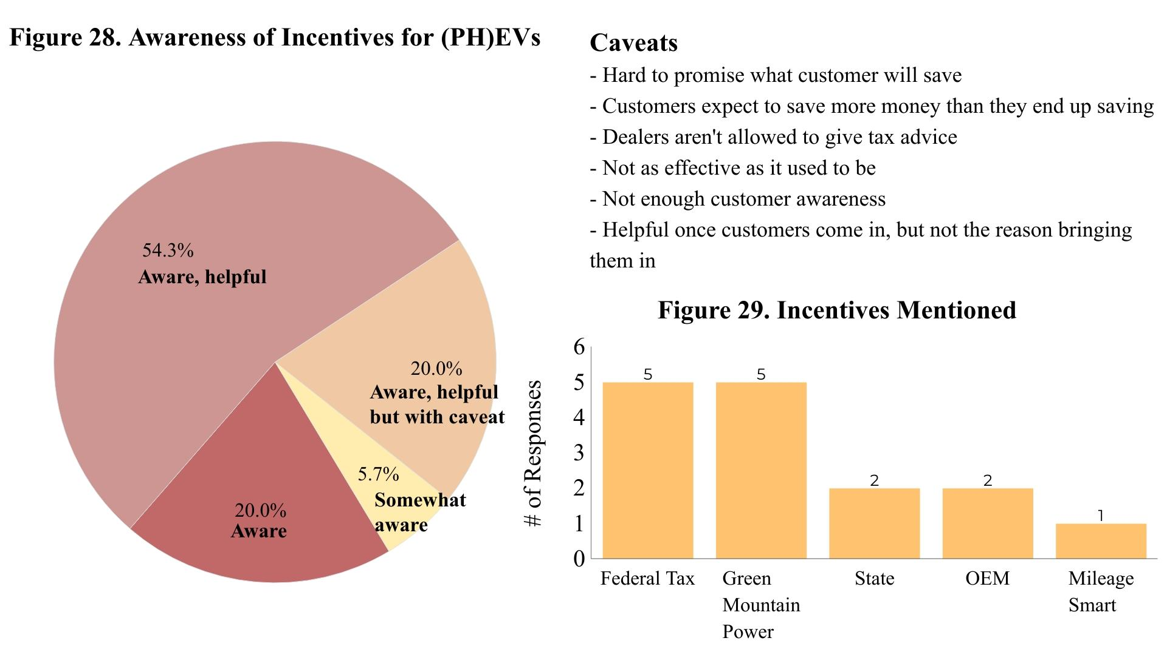

Discussion

Used Car Dealerships
Of the 85.2% who do not sell EVs and 81.5% who do not sell PHEVs in Figures 4 and 5, Figure 8 shows that most dealers did not sell these vehicles due to three main reasons: A high price, the limited availability of used models at auctions, and a lack of sufficient charging infrastructure and charging stations. Also, in a place like Vermont, consumers are very concerned about EV performance in the snow and cold weather. They are worried that the energy needed to operate and heat the vehicle in Vermont winters will severely decrease the battery life, and that the horsepower of the batteries is not sufficient for the hilly terrain in Vermont. In addition, according to Figure 3, four-wheel-drive and all-wheel-drive were the most common traits that an average customer is looking for in a vehicle, and there are very few electric models that have that. Another very important factor specific to the used market is the knowledge and technology to fix up these vehicles and re-sell them. Many dealerships mentioned they lack the information necessary to train their mechanics, and that not only are the parts inexpensive, but they are inaccessible as well. In Figure 9, when asking dealers about what kinds of support would be helpful, their answers correlated with the biggest barriers from Figure 8. The top three desired measures of support were a lower cost for dealers and consumers, more availability of used models, and more charging stations. However, it is important to note that almost 40% of the dealers who talked about barriers did not offer any thoughts on potential support, which could imply that many of these dealerships simply do not know how these barriers could be surpassed, or may not believe that these barriers can be overcome at all.
As shown in Figure 10, when it came to awareness of state incentives, 66.7% were aware of various incentives, but of those who were aware, only 11.8% thought incentives were helpful. 29.4% were aware and did not offer an opinion on helpfulness, but 58.8% believed incentives to be unhelpful, with only one respondent citing price as the primary reason. The rest of the reasons ranged from concerns about technology or infrastructure, to customer awareness. The most common reason, however, was a belief that these incentives do not target used vehicles enough. Those that were not aware of incentives overwhelmingly stated an interest in learning more about them. This information is crucial because it shows that while a high price consistently ranks as a top barrier for electric vehicles, it seems that lowering the price through incentives is not enough to override some of the other main obstacles. Therefore, while RYR’s incentive will be helpful, especially because it applies to the used market as much as it does to the new market, it will achieve more success if used in tandem with efforts to address other barriers like infrastructure, accessibility, and technology. It is also important to remember that RYR is targeted towards consumers, but if used dealerships cannot afford the high price of used EVs at auctions, which is also a commonly cited barrier, then there won’t be any EVs to offer the consumers in the first place.
Although most of the used dealerships do not currently sell EVs, the overwhelming response in Figure 6 was that they would be interested in selling them in the future. 75% of those interviewed were either interested (37.5%), potentially interested (20.8%), or would eventually be interested (16.7%). Not only did they think that the automobile industry was moving in that direction, but as the technology improves in time to deal with cold weather and snow, the consumers may be more inclined to purchase an electric vehicle as long as the infrastructure is available. There seemed to be a lot of hope to sell more EVs, but the timeline of the technology seems too slow to meet the demands of this specific market. This poses an issue because it clashes with the urgent calls to action in order to slow down the effects of climate change before they become irreversible. It also poses a challenge to RYR’s mission of having equity at the front of their project. While the population RYR aims to serve will more likely be buying from used dealerships, it seems that a robust used market for electric vehicles is at least a few years away.
In the effort to establish partnerships and relations with dealerships, we have included the most enthusiastic dealers as follows:
The representative from Roadmaster Auto Sales in St. Albans was very enthusiastic and ready to sell EVs, but can’t seem to find any used models. Similarly, the representative from Crossway Motors/Green Cars Vermont in Montpelier would definitely sell EVs if they could find a way to get them on their lots. Finally, the representative from McGee Family Used Cars in White River Junction would be very willing to sell EVs if there were more incentives targeted towards used vehicles.
Some of the least enthusiastic people we talked to were from Westminster Auto Services in Westminster, Victory Auto Sales in Rutland, Buy Right Auto Sales in East Montpelier, and Eurotech Car Sales in South Burlington. Most of these were either very pessimistic about the future or practicality of EVs, or had a very negative personal opinion of electric vehicles.
The rest of the dealerships were either mildly inclined to selling EVs, or mildly pessimistic/opposed. We recommend reaching out to the most enthusiastic dealers first, and then perhaps asking who they think might also be interested or who to reach out to next, and continue to expand RYR’s partnership web and base of trust and support until it can finally reach those who are the most opposed.

New Car Dealerships
New dealerships were more likely to be currently selling EVs and PHEVs, with 50% and 55.8% either currently selling or selling in the near future respectively according to Figures 20 and 21. Even more promising, Figures 22 and 23 show that more than 80% were interested in selling (PH)EVs in the future. The most popular models according to Figures 24 and 25 include the fully electric Ford Mustang Mach E, and the Toyota Prius Prime PHEV.
However, even though new dealerships are more excited to sell EVs and are currently selling more of them, they still highlighted important barriers that should be taken into account. In Figure 26, it is shown that similar to used dealerships, limited availability and a lack of charging stations made the top three. Tied for first with limited availability, however, is range anxiety, which was the fourth biggest concern with used dealerships. Many dealerships cited limited availability either because of production delays due to Covid, or manufacturers not yet sending their models to Vermont. However, because of the commitment on behalf of manufacturers to switch to EVs, the many new models in the works, and the ending of the Covid pandemic, we predict that within a few years this barrier will no longer be a problem. That leaves, therefore, the issue of range anxiety. According to one dealership, “EVs are great locally, but no one in VT is local to anything. People might have to go 20, 30, even 40 miles just to get to a grocery store.” This sentiment was shared among many dealerships, who were worried that the kind of driving Vermonters do is not conducive to the range electric vehicles provide. One cited the problem of charging infrastructure, and how Route 89, which runs from Canada to New Hampshire, doesn’t have a single charging station. When, according to one representative, “a lot of [electric] Sedans in a reasonable price range will only go 100-200 miles in a charge,” the kind of driving Vermonters do - long trips with little stop and go traffic - the lack of infrastructure, and the long charging times prevent the range of EVs from being accessible and practical. As one representative said, “imagine you went to a gas station and had to wait 4 hours for your tank to charge.” Some thought PHEVs could be a good step because their charging times are more practical, but many were pessimistic that range would ever get to the level it needs to in order to work in Vermont.
Although the most common barriers focused on the practicality and accessibility of EVs, new dealerships’ desired support focused more on the customer and market. According to Figure 27, the top three desired measures of support were increased customer awareness, more demand, and trained salesmen. It seemed that there was a lack of education and awareness both on behalf of the customer and the salesmen that was preventing the market for EVs to reach where it needs to be. For instance, one dealer cited how there is a lot of conflicting information online, so it is especially important to have representatives who are knowledgeable and can show the customers how EVs would be practical or helpful to their own lives. Another expressed the desire for more educational tools and awareness of tools like apps where you can plan long trips, knowledge on how to use charging stations, etc. Our survey development section will go into more detail about planning potential educational events to address this need. Some salesmen were also not educated on electric vehicles, like one dealer who thought PHEVs were fully electric. In order to make sure salesmen can advocate for these vehicles and customers are excited to use them, there has to be more education on both sides. When it came to the state of the market and lack of demand for electric vehicles, some dealers mentioned that brands have not done a good job of advertising and marketing their EVs besides Tesla. One mentioned the need to keep as much familiarity as possible in order to ease the transition and not scare people away with drastic change. However, on the other side, some were optimistic, claiming “it’s gonna happen pretty naturally, it’s just a matter of getting the word out.”
When it came to incentives, detailed in Figure 28, there was an overwhelming sentiment that incentives were helpful, and every new dealership we talked to was aware of at least one incentive. The most common incentives mentioned were the federal tax incentive and Green Mountain Power incentive. Although a majority believed incentives to be helpful, 20% of dealerships included certain caveats that were mostly centered around the ambiguity of some incentives and worry about their responsibilities as a dealership.
For instance, many dealers were worried about managing the expectations of customers, as it is hard to promise exactly what a customer will save. According to one, “someone may come in with the impression of qualifying for the incentives, and we have to break it to them that they only qualify for 50%.” Another mentioned how “the last thing we wanna do is over promise our customer,” as this would reflect badly on the dealership and hurt business for them. One dealership estimated that “90% of why people actually steer towards electric vehicles is because of the incentives. If it weren’t for that, I don’t think people would even think twice about getting EVs.” If incentives truly are such an important reason for the decision to buy an electric vehicle, then there has to be more clarity and awareness on what incentives are out there, and how they work. A potential recommendation would be to provide car dealerships with a fact sheet or infographic on the different incentives, and how much customers would save based on their socioeconomic backgrounds. This would provide a clear guide for dealerships which they could then show to their customers in order to spread more awareness and correct information around incentives.
Again, we have compiled a list of the most enthusiastic and most opposed dealerships we encountered:
The most enthusiastic include Coggins Honda of Bennington who mentioned that they were very excited to sell EVs, Alderman Chevrolet/Buick/GMC in Rutland who boasted about being one of the biggest sellers of the Chevrolet Bolt, Lamoille Valley Ford in Hardwick, and Twin State Ford in St. Johnsbury. We also recommend reaching out to Volkswagen in South Burlington. They currently have a training program to teach salesmen how to help customers learn about electric vehicles and how to use them. It would be helpful to learn more about this training program and see if other dealerships can implement something similar.
Some of the most opposed include Ted Green Ford in Stockbridge. This dealership was so concerned about range anxiety that they sarcastically told us the most important measure of support was cell service in Vermont, so people can call for help when they are inevitably stranded. Wells River Chevrolet in Wells River was worried about the cost for their dealership. They mentioned how it is very expensive for the dealership to have to pay for equipment, parts, training, etc and don’t feel financially supported to make that transition. Finally, Midstate Dodge in Barre was also worried that switching to electric vehicles was not financially feasible for the dealership.
We suspect that the many incentives already in place for new dealerships is the reason why high price was a larger barrier than range anxiety for used dealerships. It may be that because used dealerships have barriers to entry, they are more concerned with those than potential barriers once their customers start to buy and use electric vehicles. New dealerships, however, don’t have to worry about price as much, and therefore are more focused on the practicality of EVs in Vermont and the awareness of their customers on how to use their new vehicles. These issues must be addressed especially so that once used dealerships are able to move past price-related barriers to entry, they can achieve a smoother transition based on lessons and experiences from the new dealerships.

Survey Development and Future Steps with Community Action Organizations

Methods
At the core of Replace Your Ride is climate equity and justice. In order for climate action to be effective, it is essential to include all communities, especially marginalized groups. We have been tasked with designing a survey that will be given to eligible Vermonters and possible participants to create an open dialogue about their comments and concerns with the program. The Community Action Organizations are a key player in our outreach efforts as well because these types of organizations are trusted within lower-income and minority communities. Historically, minority groups have been misled by government agencies and therefore currently have a complicated relationship and hesitation toward top-down programs. By partnering with the Community Action Organizations, RYR will be able to build a working relationship with the community, adjusting the program under the guidance of organizations familiar with possible participants.
To understand the success of past EV programs, we researched programs such as Clean Cars 4 All initiative in California, the Clean Vehicle Rebate Project in California, the Consumer Assistance Program in California, the Scrap-It program in British Columbia, the Cheapr Program in Connecticut, the Mileage Smart program in Vermont, and the Cash for Clunkers program in Vermont. We looked into their intended participants and found that the structure of these programs were very similar to RYR’s existing structure. It was difficult to track down information about the beginning stages of their programs including possible surveys but we found that these initiatives provided us with a great model of success.
To get a sense of survey formatting and question inspiration, we read the “Small Town and Rural Voters’ Views of Investments Related to the Transportation and Climate Initiative” survey by the Nature Conservancy, the “Clean Transportation Strategies for Rural Communities in the Northeast and Mid-Atlantic States” survey by the Union of Concerned Scientists, the “Electric Vehicle” survey by Deloitte, and the “Consumer Interest and Knowledge of Electric Vehicles” survey by Consumer Reports. The Consumer Reports survey was especially helpful and acted as a template for our survey construction in relation to question content and formatting.
Finally, in order to assess future steps with community action organizations, we referenced the Cadmus Group Community Action Guide and Community Planning Toolkit most frequently. These provided a good overview of how we should approach the surveys and future steps, specifically prompting us to take a step back and look at the larger goal of our project. The Community Planning Toolkit provided a guide to pros and cons of different approaches to in-person outreach.

Results and Discussion
Survey and Interview Questions:
After completing our background research, we have created two sets of questionnaires. The first is a comprehensive list of questions to be used for the Community Action Organizations. Please see Appendix C for the full list of Community Action Organization questions. Three sample questions are listed below.

1. What is your understanding of RYR? What are you optimistic about? What are you skeptical of?
2. Do you see this project as being helpful to the demographic that you serve?
3. What medium do you think would be the most effective for a participant survey (i.e., email, text, telephone, mail)?

When reaching out to the Community Action Organizations whether in person or via online platform, it would be best to include the infographic found in Appendix C. The inclusion of the graphic will help familiarize the Community Action Organizations with some quick, memorable statistics about the program. It can also be a working document for the organizations to give their opinion on, in order to continue changing the language so that it will be best received by potential participants of the program.
Our second set of questions is in the form of a participant survey to assess the structure of RYR. To determine which members of the community qualify, and therefore are the targets of this survey, we propose that the RYR team use the 2020 Census data. This will be the most up to date record of income and residency. Within the survey are a section of baseline questions followed by a prompt about RYR. After the participant is familiar with the concept of RYR, they will answer another series of questions directly related to the structure of the program. Please see Appendix C for the full list of questions for the participant survey. A sample baseline and RYR question, respectively, include:

1. Please describe your living situation. Please check that all apply.
  - Rent house
  - Rent apartment
  - Own house
  - Rural
  - Urban
2. Here are some attributes that an electric vehicle might have. Which of these would most encourage you to purchase an EV? Please check all that apply.
- Costs less to charge than fueling a gasoline vehicle
  - Lower maintenance costs than a gasoline vehicle
  - A purchase price similar to a gas powered vehicle in the same class
  - Ability to charge at home
  - Higher reliability than gasoline powered
  - No exhaust fumes
  - Not having to pump gas
  - Better acceleration than gasoline powered
  - Little engine noise
  - Attractive style

The goal of the participant survey is to assess any barriers that may have been missed during the development of the project. It is important to create a working relationship with the communities in which RYR will be most effective, especially since justice and equity is at the core of successful environmental action and RYR. It is crucial to treat the community as partners of the program rather than force the incentive on them. As the Cadmus survey pointed out, many people within marginalized communities tend to have complicated relationships with government and authority figures due to past injustices. In order to effectively combat climate change, the effort must be inclusive of all communities regardless of wealth, race, party, etc. We think that our survey involves key participants early on, allowing for the highest level of success for RYR.

Conclusion and Future Steps

Following the construction of the survey and interview questions, we have completed a plan for future planning of RYR to help with the beginning phases of implementing this program. We propose two key steps:

- Focus groups
- In-person events
  - Charging station and general EV operation tutorials
  - Program information tabling events

Assuming that Covid-19 will allow for some semblance of normalcy due to vaccinations by this summer, we propose that all of these events take place in-person, if possible. It cannot be assumed that everyone has access to in-home Wi-Fi connection that would allow for exclusively online events. Focus groups are a great way to have detailed conversations that will not be captured in the survey, especially if it is done by mail or online. An experienced facilitator will be needed for this setting. Facilitators may be members of community action organizations or from the RYR team. Facilitator training courses are available in person or online such as Training Resource Group.
As our GIS map data has shown, electric vehicle infrastructure remains limited in the counties where the most eligible RYR Vermonters live. This impacts the overall view of EVs, making them more abstract because they are not present in these communities. For example, the car dealership phone survey highlighted range anxiety and battery life as key concerns to EV ownership even though there have actually been advances in EV technology that address these issues. The impressions of EVs are not up to date and this disconnect might be one of the causes of consumer hesitation. We propose that events that are woven into the community fabric will be the most effective in spreading awareness and encouraging people to take advantage of RYR. According to the Community Planning Toolkit, organizing events or holding tabling booths at already established events in a community such as farmers markets or festivals are a great way to utilize existing foot traffic. Participants can leave feeling more confident about using an EV and more informed about RYR in general. The infographic we created that was originally used during Community Action Organization interviews can be modified to become a flyer or poster for participants to take home. Please refer to Appendix B for the infographic.
In conclusion, the work we have done this semester provides Replace Your Ride with more information and guidance about the direction of the program. Combining the information informed by the GIS maps and the outreach materials, we have identified where RYR may be most effective. Based on the GIS data, we propose that RYR outreach be done in Rutland and Windham counties in particular. They have a high percentage of Vermonters who meet income eligibility requirements while also owning a car 2011 or older. In addition, there is enough existing charging infrastructure available in these counties that can be built upon. After implementing the survey, depending on the timeline of the outreach, we suggest conducting in-person outreach events over the summer at events in populated towns such as Rutland and Brattleboro. In the summer when the weather is nice and people can gather outdoors, community events such as Fourth of July celebrations would be a great way to spread awareness about the program. There will likely be already existing events that RYR can partner with which is another benefit. In addition, a national celebration such as Independence Day is mostly non-partisan and unbiased and therefore, there is a high likelihood that the event support will be strong.

Appendix A: Baseline Maps

Registered Electric Vehicles in Vermont

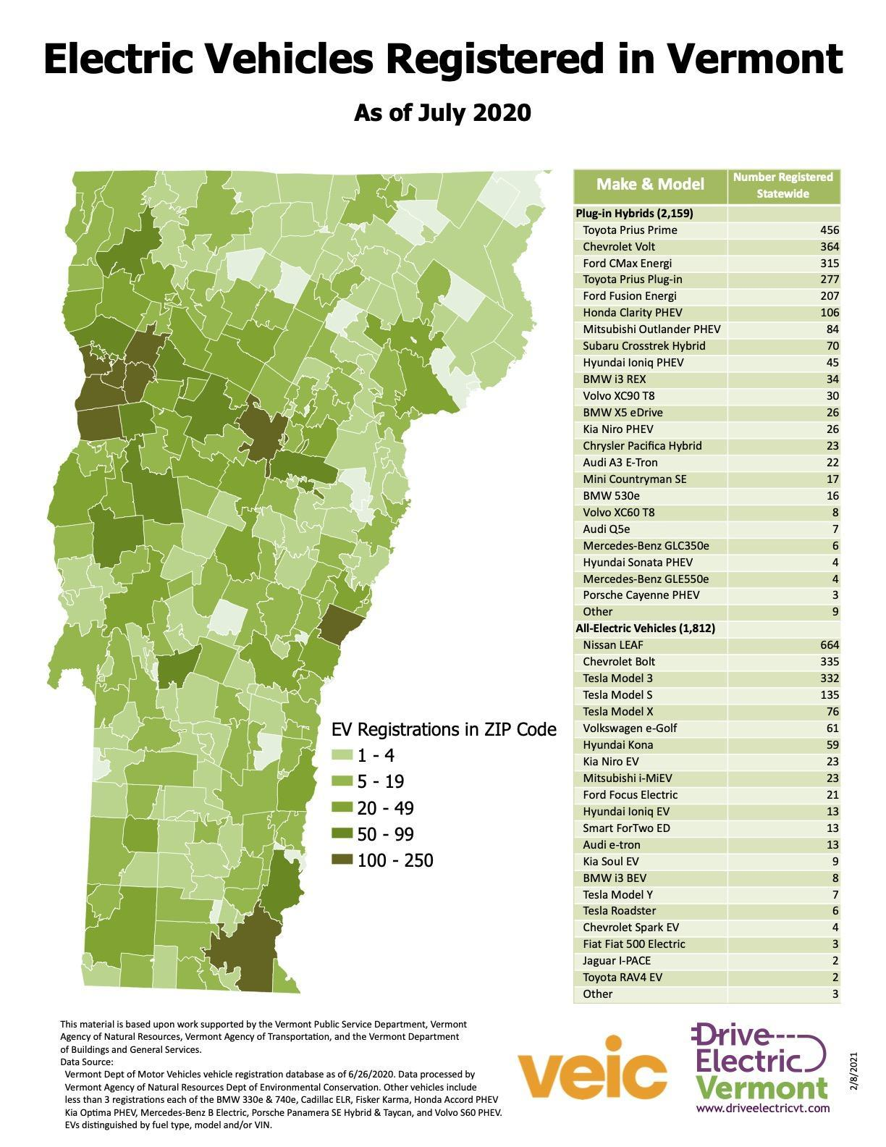

Concentration of Electric Vehicles in Vermont
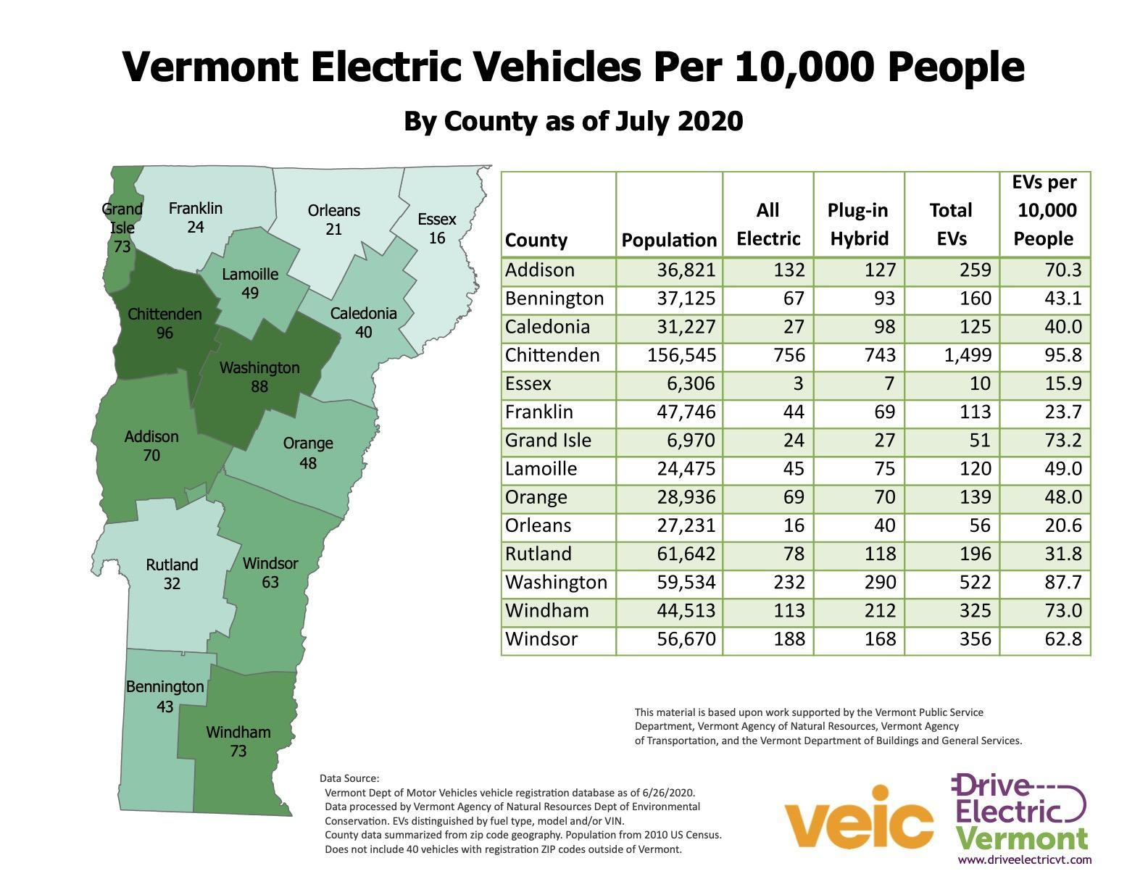

Transportation Burden in Vermont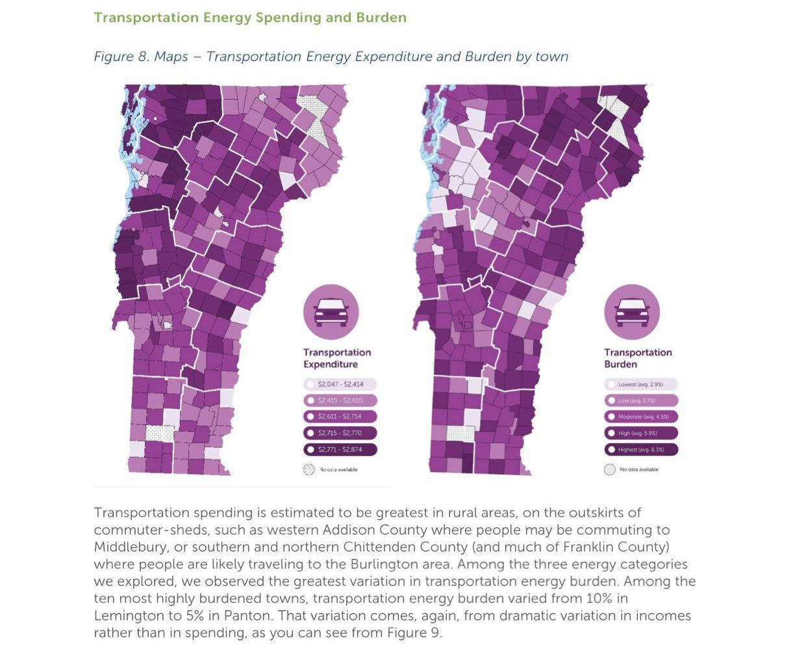

Median Household Income in Vermont
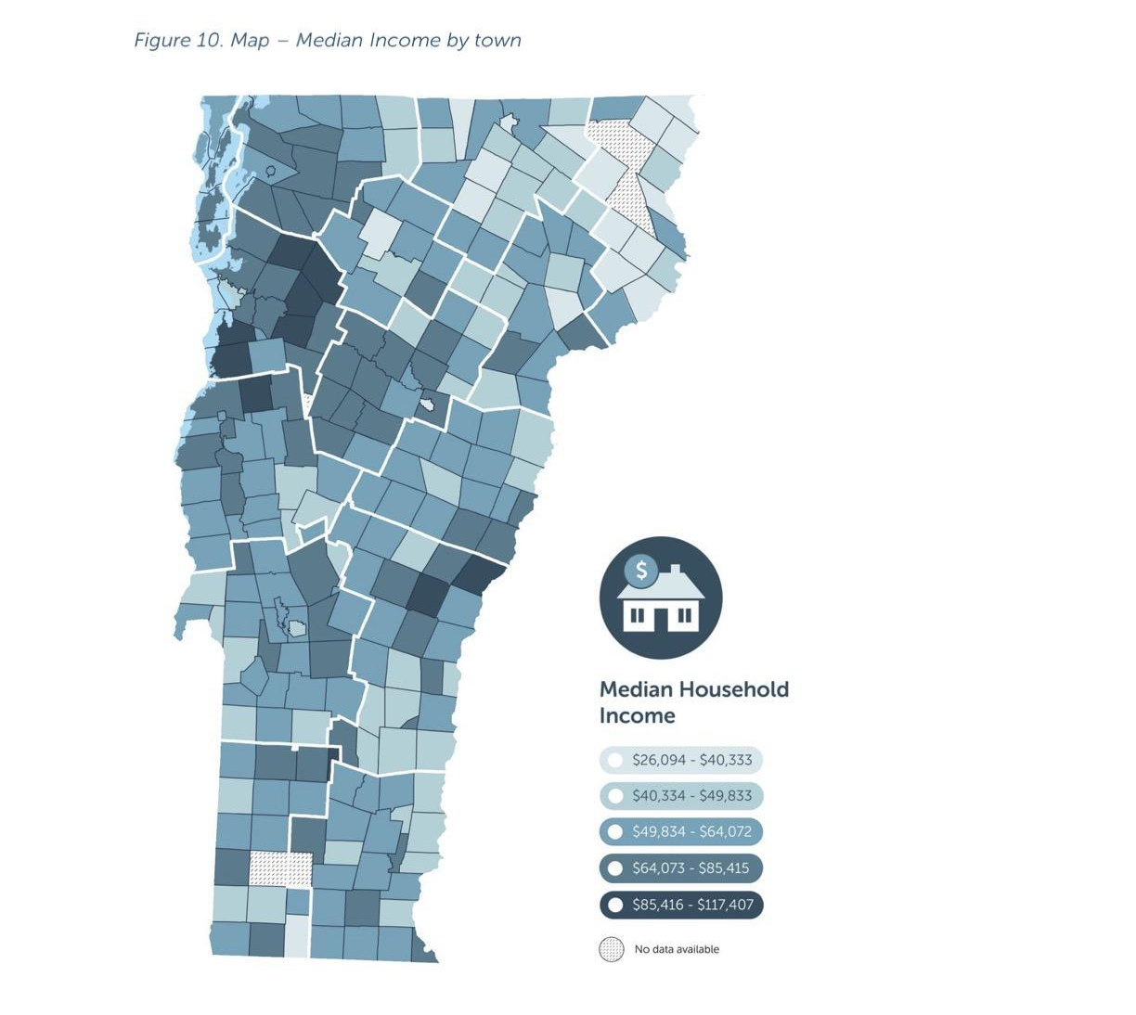

Appendix B: Outreach Materials

Infographic
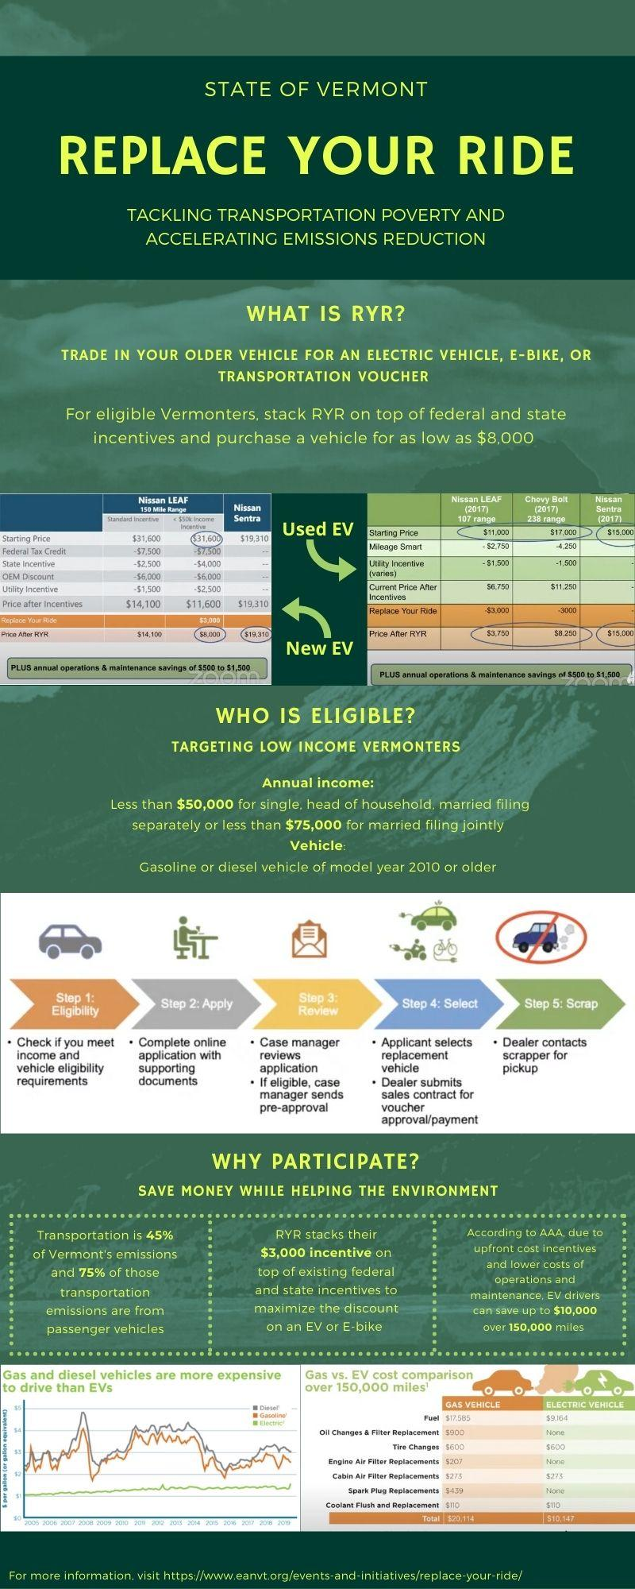
Graphic 1. We created this infographic for the purpose of providing quick and easy-to-read information about Replace Your Ride. This infographic can be used as a precursor for interviews with Community Action Organizations. In addition it can be adapted and adjusted to become a flyer or pamphlet for in-person events.

Car Dealership Script

For Used Car Dealers:
Hi! I am a Middlebury student helping to research Electric Vehicles available for sale in Vermont. This information will be used to help in the development of programs that will provide incentives for low to moderate income Vermonters for purchase of new and used electric vehicles.

- Would you be willing to answer a few questions for me?
  - No
    - Is there someone else at your dealership who I might be able to speak with or can I call another time?
    - Thank you for your time. [end]
  - Yes
    - Do we have your permission to record this call for the purpose of cross-checking our notes?
- In general, what are your most popular vehicle models?
- What is the average model year of the vehicles you sell?
- What price points for cars are best sellers?
- What do you think your average customer is looking for in a used vehicle?
- Do you currently sell fully Electric Vehicles?
  - If no: Would you be interested in selling them in the future?
- What are the barriers to selling fully electric Vehicles?
- Do you currently sell Plug in hybrids vehicles?
  - If no: Would you be interested in selling them in the future?
- What are the barriers to selling plug-in hybrid vehicles?
- (If they said yes to selling EVs and/or PHEVs): Which electric or plug in hybrid models are you getting onto your lots; and which models are the most popular with your customers?
- What would help support your work to sell electric vehicles?
- Are you aware of the state electric vehicle incentive?
  - If yes: has it proven helpful in selling EVs?
  - If no: would you like to learn more about it?
- Could I have your name in case we would like to follow up in the future?
  - If we include a quote from this interview in our final report, do we have permission to use your name?
    - If no: Could we use the name of this car dealership instead?
  - Would you like us to share these quotes with you for your review before publishing anything?
    - If yes: how can we best reach you?
Thank you so much for your time!

For New Car Dealerships:
Hi! I am a Middlebury student helping to research Electric Vehicles available for sale in Vermont. This information will be used to help in the development of programs that will provide incentives for low to moderate income Vermonters for purchase of new and used electric vehicles.

- Would you be willing to answer a few questions for me?
  - No
    - Is there someone else at your dealership who I might be able to speak with or can I call another time?
    - Thank you for your time. [end]
  - Yes
    - Great! Thank you. Do we have your permission to record this call for the purpose of cross-checking our notes?
- In general, what are your most popular vehicle models?
- What is the average model year of the vehicles you sell?
- What price points for cars are best sellers (for new and for used cars)?
- What is your average customer looking for in a car?
- Do you currently sell fully Electric Vehicles?
  - If no: Would you be interested in selling them in the future?
- What are the barriers to selling fully electric Vehicles?
- Do you currently sell Plug in hybrids vehicles?
  - If no: Would you be interested in selling them in the future?
- What are the barriers to selling plug-in hybrid vehicles?
- What would help support your work to sell electric vehicles?
- (If they said yes to selling EVs/PHEVS): Which electric or plug-in hybrid models do you offer; and which EV/PHEV models are the most popular with your customers?
- Add: Are you aware of the state electric vehicle incentive?
  - If yes: has it proven helpful in selling EVs?
  - If no: would you like to learn more about it?
- Could I have your name in case we would like to follow up in the future?

Thank you so much for your time!

Car Dealership Survey Data

Spreadsheet for Used Dealerships

Spreadsheet for New Dealerships

Appendix C: Survey and Interview Questions

CAP Interview Questions
- What is your understanding of RYR? What are you optimistic about? What are you skeptical of?
  - What questions do you have about the project?
- Do you see this project as being helpful to the demographic that you serve?
- What do you think is easy about this program, and what might be more challenging?
- How has Mileage Smart been going? What are your main critiques of that program? What have been the biggest challenges of that program?
- What do you think is the best way to raise awareness and interest around this project?
  - Have you had a chance to look over the infographic we provided? Could you see your organization utilizing that when communicating to your constituents? What kinds of suggestions or criticisms do you have on the infographic?
    - What kind of language is best for communicating with your audience?
- How can we best reach lower income communities? Do you think they would be receptive to a program like this? If not, how can we frame/change the program to better meet their needs or interests?
- What tools or support would you need from EAN in order to promote this project?
- Would you be willing to purchase a new vehicle in the next 5 years? Would that be an electric vehicle?
- (If RYR and EVs don’t seem to be a good place to make change for this population,) what other places might there be room for state incentives to help foster environmental change?
- What are some other trusted organizations (formal or informal) in your communities that would be beneficial in reaching out to participants?

Participant Survey Questionnaire
Baseline Questions:
- Please describe your living situation. Please check that all apply.
  - Renting house
  - Renting apartment
  - Own house
  - Rural
  - Urban
- What Vermont county do you live in?
  - Addison
  - Rutland
  - Chittenden
  - Windsor
  - Essex
  - Orange
  - Caledonia
  - Orleans
  - Franklin
  - Grand Isle
  - Lamoille
  - Bennington
  - Windham
  - Washington
- Do you currently own or lease a plug-in electric vehicle?
  - Yes
  - No, I have never
  - No, but I have in the past
- What is the estimated annual cost of your current transportation option (gas, maintenance, insurance, taxes)?
  - Less than $1,500
  - $1,500 - $2,500
  - More than $2,500
- Is the annual transportation cost a burden on your annual finances?
  - Yes
  - No
- How often do you use your current transportation option?
  - Every day
  - 3-5 times a week
  - Once a week
  - Less than once a week
- What do you mostly use transportation for?
  - Commuting
  - Grocery shopping and other errands
  - Recreational travel
  - Other: _____
- How often do you fill up the gas tank?
  - Once a week
  - Once every two weeks
  - Once a month
  - Less than once a month
- If you could make improvements to your transportation option, what would they be?
  - ________________
- Do you know about these programs in your community? Please check all that apply.
  - Transit
  - RideShare
  - Vanpool
  - CarShare
  - Biking/e-biking
  - Other
- How would you describe your knowledge of Electric Vehicle operations and charging stations?
  - I know a lot about them and how to use them
  - I know a little bit about them
  - I know nothing about them
- What is your knowledge of state and federal incentive programs for Electric Vehicles?
  - I know lots about them/I have participated in them
  - I know about them but haven’t used them
  - I don’t know about them at all
- If you were buying a new vehicle (new or used) this year, how much would you spend on it?
  - $5,000 - $8,000
  - $10,000 - $15,000
  - $15,001 - $20,000
  - $20,001 - $25,000
  - $25,001 - $30,000
  - More than $30,000

RYR Introduction
Replace Your Ride is a Vermont state program that strives to provide financial assistance for low-income Vermonters to switch over to clean electric options affordably. The program would offer up to $3,000 cash incentives (that can be staked up existing state and federal incentives) for new or used electric vehicles, electric-bikes, public transportation vouchers, or ride-share vouchers while scrapping their older, high polluting vehicle. Not only can this provide affordable transportation options for Vermonters who need it, the program will help accelerate the reduction of greenhouse gas emissions coming from Vermont’s transportation sector. Please answer the following questions to tell us your thoughts on the program and to help Replace Your Ride design it to best fit your needs.

Questions prompted by RYR
- Here are some attributes that an electric vehicle might have. Which of these would most encourage you to purchase an EV?
  - Costs less to charge than fueling a gasoline vehicle
  - Lower maintenance costs than a gasoline vehicle
  - A purchase price similar to a gas powered vehicle in the same class
  - Ability to charge at home
  - Higher reliability than gasoline powered
  - No exhaust fumes
  - Not having to pump gas
  - Better acceleration than gasoline powered
  - Little engine noise
  - Attractive style
- Which of the following statements best describes your thoughts on buying or leasing an EV?
  - I definitely plan on getting an EV for my next vehicle
  - I would consider it
  - I have some interest for the future but not my next vehicle
  - I have no interest
- Which of the following are barriers to hold you from purchasing an EV?²¹
  - Public charging stations
  - Purchase prince
  - Driving range
  - Nowhere to charge at home
  - Longer charging time
  - I don’t know enough about the EVs that are available and how to operate them
- If an electric vehicle exceeded all the barriers from the question above, what is the likelihood that you would actually purchase an EV?
  - Very Likely
  - Likely
  - Not Likely at all
- The initial price of EVs may be a little bit higher than gas powered vehicles but there are larger savings overtime because there is no need to fill gas and maintain services like oil. How quickly would savings need to offset the initial cost for you to be willing to pay a little bit more for a more fuel efficient vehicle?
  - Within the first month
  - One to 3 months
  - 3 to 6 months
  - 6 months to a year
  - 1 - 2 years
  - 2 - 5 years
  - Over the lifetime of the vehicle
  - I would be willing to pay more even if I don’t end up offsetting the initial cost over time.
- Would you most likely purchase a new or used EV?
  - New
  - Used
  - Either
- Do you know how to use an EV charging station?
  - No
  - Yes
- Do you know where the nearest EV charging station is to your home or work?
  - No
  - Yes
- If an electric vehicle is not the best option for you, would you consider an electric bike?
  - Definitely
  - Maybe
  - Probably not
  - No
- Are you familiar with the public transportation options near you?
  - Yes
    - If yes, do you use public transportation?
      - Yes
      - No
    - Does it meet your transportation needs?
      - Yes
      - No
  - No
- Would you be more likely to use your local public transportation if you had a voucher?
  - Yes
  - No
  - Maybe
- Would you be willing to trade in your gas powered vehicle for a public transportation voucher?
  - Yes
  - No
  - Maybe
- Have you participated in a state or federal initiative before?
  - No, but if I am eligible I would want to
  - No, I will ever
  - Yes.
    - Which one: _________
- With the money you save annually from owning an EV, what would you use those funds for instead?
  - Food
  - Housing
  - Recreation
  - Other: ______
- Would you take advantage of this incentive now?
  - Yes
  - No, not at the moment but I would in the future
  - No, I would never
- What would make this incentive more appealing to you?
  - ________________
- What are you optimistic about in terms of this program?
  - ________________
- What are you skeptical about in relation to this program?
  - ________________
- When you purchase a vehicle, do you care about what other people might think of your new car?
  - Yes
  - No
  - Maybe
- Do you think that electric cars improve the environment?
  - Not at all
  - Unsure
  - Somewhat
  - Definitely
- How do you envision Vermont reducing it’s fossil fuel consumption? And the country?
- How do you engage in sustainable behavior currently?
  - Recycling
  - Carpooling
  - Renewable energy (i.e. solar panels, wind, hydroelectric)
  - Composting
  - Other: ________
- Would you be willing to continue this conversation in a focus group with other members of your community?
  - Yes
  - No
  - Maybe
- Would you attend an event that would teach the community about EV and charging station operations?
  - Yes
  - No
  - Maybe

Bibliography
California Air Resources Board. (2016).Clean Cars 4 All. State of California. https://ww3.arb.ca.gov/msprog/lct/vehiclescrap.htm
California State Legislature. (2017). Assembly Bill No. 630. California Legislative Information. https://leginfo.legislature.ca.gov/faces/billNavClient.xhtml?bill_id=201720180AB630
Choksi, N. (2021, March 31). Biden’s Push for Electric Cars: $174 Billion, 10 Years and a Bit of Luck. The New York Times.
https://www.nytimes.com/2021/03/31/business/biden-electric-vehicles-infrastructure.html
Community Places. (2014). Community Planning Toolkit. BIG Lottery Fund. https://www.communityplanningtoolkit.org/sites/default/files/Engagement.pdf
Connecticut Department of Energy and Environmental Protection. (2021). CHEAPR: Connecticut Hydrogen and Electric Automobile Purchase Rebate. CHEAPR. https://portal.ct.gov/DEEP/Air/Mobile-Sources/CHEAPR/CHEAPR---Home
Consumer Reports. (2020). Electric Vehicles and Fuel Economy. Consumer Reports. https://article.images.consumerreports.org/prod/content/dam/surveys/Consumer_Reports_Electric_Vehicles_Fuel_Economy_National_August_2020
Deloitte. (2017). Deloitte Utility Electric Vehicle Survey. Deloitte. https://www2.deloitte.com/content/dam/insights/us/articles/3851_FoM-Power-and-utilities/Deloitte%20Utility%20EV%20Survey%20FINAL.pdf
Department of Consumer Affairs. (2021). Consumer Assistance Program. State of California. https://www.bar.ca.gov/Consumer/Consumer_Assistance_Program/
Efficiency Vermont. (2021). Vermont’s Total Energy Burden by Town. Efficiency Vermont. https://www.efficiencyvermont.com/news-blog/whitepapers/vermont-energy-burden
Energy Action Network. (2019). Transportation Electrification in Vermont. Energy Action Network.
https://www.eanvt.org/featured-news/transportation-electrification-in-vermont/
Facilitator Training Program. TRG. https://www.trg-inc.com/our-services/facilitator-training-program/
Governor Scott marks adjournment of the 2021 legislative session. Vermont Biz. (2021, May 22).
https://vermontbiz.com/news/2021/may/22/governor-scott-marks-adjournment-2021-legislative-session
Krosnick, J., MacInnis, B. (2020). Technical Report:Climate Insights 2020 | Electric Vehicles. Stanford University. https://media.rff.org/documents/Terchnical_Report_Electric_Vehicles27605.pdf
Lowel, D., Van Atten, C., Culkin, J., Langlois, T. (2020). Clean Transportation Strategies for Rural Communities in the Northeast and Mid-Atlantic States. Union for Concerned Scientists. https://www.ucsusa.org/sites/default/files/2020-11/rural-transportation-opportunities.pdf
Scott reveals $1 billion economic recovery and revitalization plan. Vermont Biz. (2021, April 6).
https://vermontbiz.com/news/2021/april/06/scott-reveals-1-billion-economic-recovery-and-revitalization-plan
Scrap-It. (2021). Scrap vehicle rebate and incentives for residents. Scrap-It.
https://scrapit.ca
The Cadmus Group. (2018). A Guidebook on Equitable Clean Energy Program Design for Local
Governments and Partners. Urban Sustainability Directors Network.
https://cadmusgroup.com/wp-content/uploads/2018/09/Cadmus-USDN-EquitableClean-Energy-Guidebook.pdf
The Nature Conservancy. (2019). Small Town & Rural Voters’ Views of Investments Related to the Transportation and Climate Initiative a Clean Transportation Fund in the Northeast & Mid-Atlantic. The Nature Conservancy. https://www.nature.org/content/dam/tnc/nature/en/documents/TNC_TCI_Survey_2019_Public.pdf
Vermont House Committee on Transportation. (2021). House Committee on Transportation 02-10-2021-03 [Video]. YouTube. https://www.youtube.com/watch?v=kuM7GIZ5uOU&t=3912s
Vermont House Committee on Transportation. (2021). House Committee on Transportation 02-25-2021-01 [Video].YouTube. https://www.youtube.com/watch?v=ILDBXk_BcC4&t=3s
Vermont Natural Resources Council. (2021). Climate Dispatch—March 12, 2021: Gabrielle Stebbins [Video]. YouTube.
https://www.youtube.com/watch?v=T1B9qtroJiw
Vermont State Legislature. (2021). Income Eligibility Updates. Vermont General Assembly. https://legislature.vermont.gov/Documents/2022/WorkGroups/House%20Transportation/Bills/H.433/Drafts,%20Amendments%20and%20Legal%20Documents/W~Anthea%20Dexter-Cooper~DR%2021-0655,%20Draft%202.1,%203-10-2021,%20Income%20Eligibility%20Updates~3-10-2021.pdf
VTrans. (2019). The Vermont Transportation Energy Profile. State of Vermont Agency of Transportation. https://vtrans.vermont.gov/sites/aot/files/planning/documents/planning/The%20Vermont%20Transportation%20Energy%20Profile_2019_Final.pdf

Data Sources
- VT_ Data_County_Boundaries, polygon, epsg: 32145, all Vermont Counties.
  - Source: Vermont Open Geodata Portal at https://geodata.vermont.gov/datasets/vt-data-county-boundaries/data?geometry=-79.594%2C42.478%2C-65.290%2C45.249
- VT_Electric_Vehicle_Charging_Stations, point, epsg: 32145, electric vehicle charging locations in vermont.
  - Source: Vermont Open Geodata Portal at https://geodata.vermont.gov/datasets/accd::vt-electric-vehicle-charging-stations?geometry=-76.441%2C43.393%2C-69.289%2C44.774
- VT_Data_-_Public-Transit-Routes_From_GTFS_Data-feeds, polygon, epsg:32145, Public-transportation route and stop layers derived from GTFS (General Transit Feed Specification) feeds.
  - Source: Vermont Open Geodata Portal at https://geodata.vermont.gov/datasets/vt-data-public-transit-routes-from-gtfs-data-feeds?geometry=-79.952%2C42.428%2C-65.648%2C45.202
- VT_Data_-_Public-Transit-Stops_From_GTFS_Data-feeds, points, epsg:32145, Public-transportation route and stop layers derived from GTFS (General Transit Feed Specification) feeds.
  - Source: Vermont Open Geodata Portal at https://geodata.vermont.gov/datasets/vt-data-public-transit-stops-from-gtfs-data-feeds?geometry=-79.935%2C42.430%2C-65.631%2C45.204
- VT_Park_and_Ride, point, epsg: 32145, locations of parking areas for the VT park and ride program.
  - Source: VT Open Geodata Portal at https://geodata.vermont.gov/datasets/VTrans::vt-park-and-rides?geometry=-79.635%2C42.403%2C-65.331%2C45.178
- VT_2010_Census_Block_Boundaries_and_Statistics, polygon, epsg:32145, Vermont block groups and corresponding census data from 2010.
  - Source: https://geodata.vermont.gov/datasets/vt-2010-census-block-boundaries-and-statistics?geometry=-79.594%2C42.477%2C-65.290%2C45.249
- SE:A14001 Household Income (in 2019 inflation adjusted dollars), CSV, no geometry, data containing percentages of county at different ranges of income.
  - Source: https://www.socialexplorer.com/tables/ACS2019_5yr/R12812016

Roberts, D. (n.d.). Transportation Electrification in Vermont. Energy Action Network.
Ibid
Consumer Interest and Knowledge of Electric Vehicles. Consumer Reports. (December 2020), 3.
Consumer Interest and Knowledge of Electric Vehicles. Consumer Reports. (December 2020), 12.
Consumer Interest and Knowledge of Electric Vehicles. Consumer Reports. (December 2020), 3.
Consumer Interest and Knowledge of Electric Vehicles. Consumer Reports. (December 2020), 4.
Consumer Interest and Knowledge of Electric Vehicles. Consumer Reports. (December 2020), 18.
Facilitator Training Program. TRG.
Sears, J., & Lucci, K. (2019, October). Vermont Energy Burden Report. Efficiency Vermont.
Annual Progress Report. Energy Action Network. (2020). & Sears, J., & Lucci, K. (2019, October). Vermont Energy Burden Report. Efficiency Vermont.
Lowell, D., Van Atten, C., Culkin, J., & Langlois, T. (2020, November). Clean Transportation Strategies for Rural Communities in the Northeast and Mid-Atlantic States. Union of Concerned Scientists.
Wegel, L., & Hahne, K. (2019, September 27). Re: Small Town & Rural Voters’ Views of Investments Related to the Transportation and Climate Initiative a Clean Transportation Fund in the Northeast & Mid-Atlantic. The Nature Conservancy.
Deloitte Utility Electric Vehicle Survey. Deloitte.
Consumer Interest and Knowledge of Electric Vehicles. Consumer Reports. (2020, December).
Curti, J., Anderson, F., & Wright, K. (2018, September). A Guidebook on Equitable Clean Energy Program Design for Local Governments and Partners. The Cadmus Group.
Community Planning Toolkit - Community Engagement. Community Places. (2014).
Clean Cars 4 All. Moving California.
Scrap Vehicle Rebates and Incentives for BC Residents. Scrap-It.
CHEAPR. Connecticut Department of Energy and Environmental Protection.
Save Money With Every Mile. MileageSmart.
Gayer, T., & Parker, E. (2013, October 30). Cash for Clunkers: An Evaluation. Brookings.
Drive Clean and Save. California Clean Vehicle Rebate Project.
Annual Progress Report. Energy Action Network. (2020). & Sears, J., & Lucci, K. (2019, October). Vermont Energy Burden Report. Efficiency Vermont.
Choksi, N. (2021, March 31). Biden’s Push for Electric Cars: $174 Billion, 10 Years and a Bit of Luck. The New York Times.
Annual Progress Report. Energy Action Network. (2020). & Sears, J., & Lucci, K. (2019, October). Vermont Energy Burden Report. Efficiency Vermont
Scott reveals $1 billion economic recovery and revitalization plan. Vermont Biz. (2021, April 6).
Governor Scott marks adjournment of the 2021 legislative session. Vermont Biz. (2021, May 22).

